Egypt Civilization

Ancient civilizations include the four major civilizations: Egyptian civilization, Mesopotamian civilization, Indus civilization, Yellow River civilization, and other Mayan civilizations and Inca civilizations.
Among them, Egyptian civilization and Inca civilization are very interesting in that they made mummies and built pyramids.
Learn about Egyptian civilization, look at the secrets hidden in the Great Pyramid.
1. Egyptian civilization;
Egyptian civilization was built on the agrarian industry in fertile land downstream of the Nile.
The annual flood of the Nile carried fertile sediments upstream, and the Nile was a rich land.
These floods occurred regularly, and they could predict them in advance to control the timing of farming.
Because of the flood of the Nile River, solar calendar, geometry, architecture, and astronomy have developed.
a) History
1. The period of the old Kingdom (B.C 3150 to 2060): 1 to 10 dynasties, capital: Memphis;
The first pharaoh is Menes, who unified Egypt in Sangha.
B.C. Starting in 2650, a terraced pyramid begins to be created.
2. The Middle Kingdom period (B.C 2060 to 1670): 11 to 17 dynasties, capital: Thebes;
In this era, Egyptian culture blossoms and literature develops.
1785-1570 Asians called Hicksos from the northeast invade and dominate.
3. The New Kingdom period (B.C 1570 to 525): 18 to 26 dynasties, capital: Amarna.
It was destroyed by Persia in 525 B.C.

b) Pharaohs
The King of Egypt was called Pharaoh, and was an absolute being with omnipotent power as a living god.
Pharaoh is the son of the sun god and believed that even if the body dies, his soul can always be reborn as a divine thing.
King had a lot of symbols and had a hood called Nemes on his head, had a fake beard for consciousness, and had a scepter symbolizing the kingship in my hand.
Cobra, in the middle of his head, believed that if an enemy appeared, it would shoot the fire and protect the king.
Pharaoh had the obligation to protect the nation by building and dedicating a grand temple.
Ramses II, who was crowned in 1279 BC at the age of twenty-four, built the most powerful Egyptian kingdom, reigning for 66 years.
During his reign, Ramses II had about 90 children and built a vast number of cities and temples from Tanis in the Nile Delta in the north to Abusimbel in the southern Nubia region.
He is the pharaoh who experienced 10 disasters when Moses exodused the Israelites.
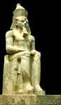  Ramses Statue | 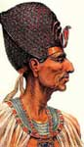  Ramses | 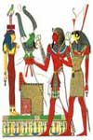  Ramses with gods | 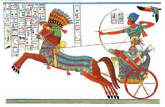  Ramses in war
Tutankhamen was crowned king at the age of 8 and became a pharaoh, but he died at the age of 17.
An autopsy found that he died of fatal damage to the brain, and it is thought that he had a tragic end, such as assassination.
The ancient Egyptian kings thought of tombs as permanent residences, and the construction of large tombs such as pyramids developed.
But all the pyramids were also stolen, and later made graves in the deep valley of the rugged stone mountains called the valleys of kings.
However, this place was not able to avoid the hands of the thief, and all were stolen and damaged.
Of all the pharaohs in Egypt, only the tomb of King Tutankhamun was preserved for 3,000 years and then excavated in 1922.
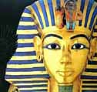  Gold Mask | 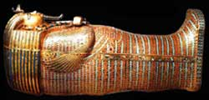  Gold coffin | 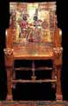  throne | Stick
c) Mummy
The Egyptians believed that after death, they lived again forever in another world.
So They wanted to enter the kingdom of eternal life ruled by King Osiris.
They believed that when a person dies, he is judged by Osiris and enter the afterlife.
And the Egyptians believed that when a person dies, the soul of a person is separated from the body and returned to this world and returned to his body.
So They made the body a mummy to preserve the body so that the soul could come back after death.
The body was treated with natural embalming salt to prevent rotting, and the bandage was wrapped around it, and when the soul returned, the mask of the face was put on the head of the mummy so that he could recognize his body.
When the king or nobleman died, he first set up a body on a ship traveling to the world and moved it to the grave and started to make a mummy.
The process of making mummies took 70 days, and it took a special skill of experts with long and difficult work.

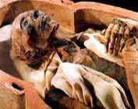  Ramses' Mummy | 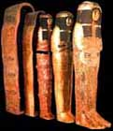  Coffin | 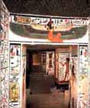  Maat goddess | 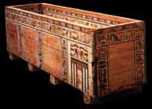  Stone cofin
d) Egyptian mythology
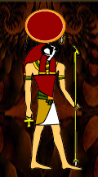  Ra | 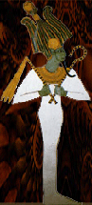  Osiris | 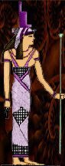  Isis | 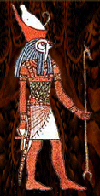  Horus
Then, Osiris married Isis and Seth married Nephtis.
Osiris gave birth to Horus, and Seth set gave birth to Anubis.
The seth envy the brother and plots, making a coffin that fits the size of the osiris, and when anyone enters the coffin and gives it to the person who fits the size, Osiris enters and closes the coffin and floats it on the Nile.
However, Osiris' wife Isis revives her husband in the underground world with the power of miracles and gives birth to Horus.
Horus grows up, revenges his father, regains his throne, becomes the best god on earth, and appears as a hawk.
After his death, Osiris became the king of the underworld and became a god to judge eternal life, and Isis is served as love and goddess.
e) Conclusion
Egyptians believe that after death, the soul goes to the afterlife, is judged and eterna lifel, and then the soul is resurrected in search of the body.
This is a very biblical belief.
Like Greek mythology, Egyptian mythology is a myth that Satan, who has been kicked out of the sky, is a myth to glorify himself.
Satan was an angel with a bull's head in heaven, and came to the ground and became a snake.
He betrayed with many angels, which are the demons, it is why the Egyptians serve many gods.
In particular, Horus is similar to Zeus in Greek mythology, and corresponds to the all seeing eye at the top of the pyramid, a symbol of Freemasonry.
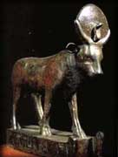  a bull-shaped Horus. | 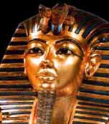  Two cobras on top of pharaoh mask | 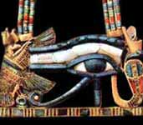  all seeing eye, symbolizing Horus of Egypt | 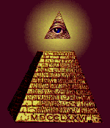  all seeing eye, on the Pyramid, the Symbol of Freemasonry

2. Maya civilization;
Mayan civilization is like Egypt in that it builds pyramids and serves the sun god, and there is a singularity that it gives people sacrifices.
There are claims that Egyptians crossed the Atlantic Ocean by boat and established Mayan civilization.
America is divided into Mayan civilizations in Central America Guatemala, Aztec civilizations in Mexico, and Inca civilizations in South America Chile.
The three civilizations have a common point that they did not use iron.
Maya and Aztec used picture letters and pyramids, but Inca does not have them.

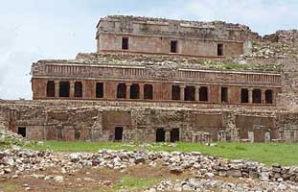 | 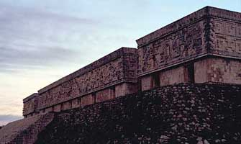
Mayan masonry as good as the Roman era
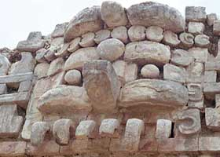 | 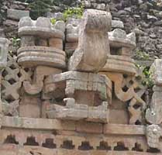 | 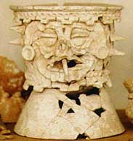
Elephant-shaped idols with sharp teeth and monster-shaped cu
b
Mayan civilization, which was destroyed by the Spanish army, can be known through the picture letters carved on the stone.
They threw a virgin into the well for sacrifice. .
Mayan civilization began at A.D. 374 and lasted until it was destroyed by the Spanish army.
Maya used 20th-degree mathematics and had excellent astronomy to calculate the year and month exactly.
Those who did not know how to use livestock, convey the heavy stones only with the power of man.
* The common between Egypt and Maya
Egypt and Maya have the same shape and material reed boats, and in 1970, an explorer crossed the Atlantic Ocean on this reed boat, proving the possibility that the Egyptians crossed into the Maya.
Egypt and Maya built a great temple and pyramids, served the sun god, made the dead a mummy, and married between royalty.
The difference is that the Egyptian pyramid is a square horn-shaped tomb with a peak top, and the pyramid of Maya is a terraced temple with a flat top.
However, the pramid of Maya was also used as a tomb of the king, such as the picture on the right side below, was discovered in 1949 in the Maya pyramid.
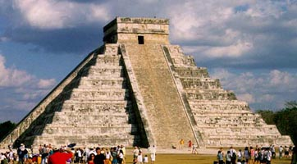 | 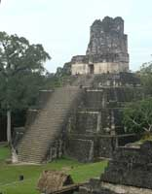 | 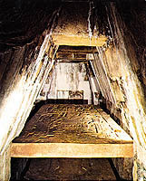

3. Egyptian pyramids
The Egyptian pyramid symbolizes the king's power as the tomb of the king.
The pharaoh built the pyramid at the same time as he was crowned.
In terms of religion, the pyramid was a space for the afterlife as a device that connects pharaohs and sun gods.
a) The history of change of pyramid
The early pyramids were terraced, turned refractory, and then finished in square horns.
However, since the Giza era, the pyramids have declined rapidly because of tomb robber.
So they secretly dug graves in the rugged stone mountains south of Egypt to establish a place for the king.
This area is called the Valley of Kings
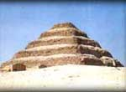  the terraced pyramid of king joseur | 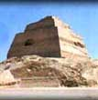  the pyramid of king hoony | 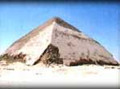  the reflexive pyramid of king snepr | 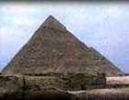  he pyramids of king capra
b) Pyramid construction
The pyramids used logs to move more than 2 to 10 tons of stones with human strength.
In order to build the Great Pyramid, more than 100,000 people have to be put in for 20 years and build 2.3 million stones.
To build a stone in the pyramid, you have to build a ramp, which is three times the pyramid volume to maintain a 1/10 slope and 1467 meters long.
But the slopes built up in soil would have to collapse and used other methods.
So what's suggested as an alternative is a spiral ramp.
The spiral ramps reduce the amount of soil used.
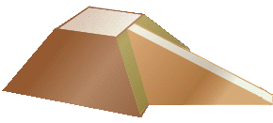  straight type ramp | spiral ramp

c) Pyramids in Giza area
The pyramids are distributed in many places, but the largest and most famous is the pyramids in the Giza area.
The Giza area has three pyramids arranged side by side.
The left Great Pyramid is said to have been built by King Kufu, the middle second pyramid by King Capre, and the right third pyramid by King Mencaure.
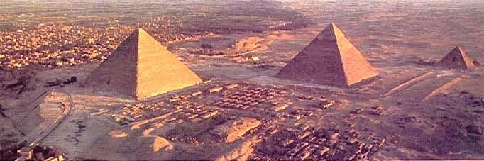

4. Great pyramids;
One of the seven biggest wonders in the world, the Great Pyramid is the largest pyramid, with a height of 147m and a height of 40 stories building.
One side is 230m long, with 2.5 million stones, 7 million tons of stone.
One strange thing, however, is that there are unique structures in the Great Pyramid that have no relics, murals, hieroglyphs, or mummy.
So there is nothing to prove that it is King Coop's tomb, and it seems to symbolize something.
a) The feature of the Great Pyramid
We know that the triangle is a regular triangle, but in fact it is a bi-isomorphic triangle.
The slope of the rainside to the bottom of the pyramid is 51° 52''.
The bottom and height of the pyramid are related by mathematical formulas.
If the bottom of the pyramid is called L and the height is h,
4L=2hπ, h=4L/2π=2L/π
In other words, the sum of the four undersides is the same as the circumference of a circle with a radius of height.
Therefore, the sum of the four bottoms symbolizes the circumference of the earth, and the height symbolizes the radius of the earth.
The pyramid is located at exactly 30 degrees above Earth's latitude.
The north side, the basic direction of the Egyptian pyramid is almost completely heading north.
The bottom of the pyramid is calculated as the cubit of the time, which is 365.4422 cubits, which is the exact year calculated by solar calendar.
The entrance of the pyramid is precisely pointing the polar star of the time.
b) The internal structure of pyramid
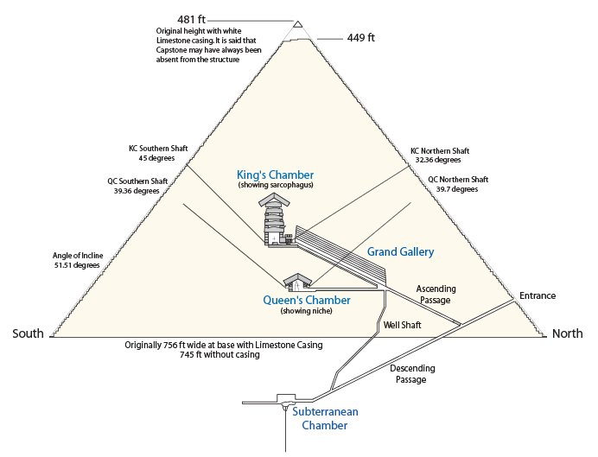
In the 9th century, there was an attempt to unearth the Great Pyramid, but it was not found to find the entrance, and the way up was found while digging.
They climbed a narrow road in anticipation of the treasure and entered the Queen's room, but it was an empty room with nothing.
There were no murals or hieroglyphs that were common in other pyramids.
The Great Corridor is a relatively wide passageway with an arched ceiling 2 meters wide and 8.5 meters high.
They went through the Great Corridor to the King's Room, but there was nothing.
In a rectangular room with a length of 10.5m, a width of 5.25m, and a height of 5.8m, there was a sarcophagus made of granite in the west, and the inside was empty.
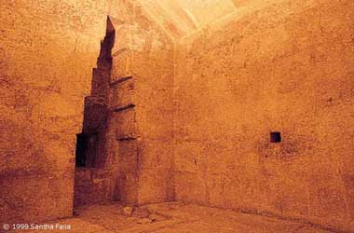  The Queen's Room,  the small hole on the right, is a ventilating hole | 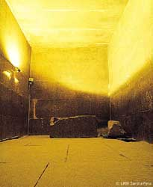  King's room and sarcophagus
What's interesting is the 20 x 20 cm ventilation hole, which is pierced from both sides in the Queen's Room and the King's Room.
It's a hole that you can't see in other pyramids, and how they drilled it is a mystery.
Because the end is blocked, It is not a ventilation hole, it seems to point to the constellation.
d) The Great Pyramid is biblical.
Job38:5~7 Who determined its measurements? Surely you know! Or who stretched the line upon it?
To what were its foundations fastened? Or who laid its cornerstone,
When the morning stars sang together, And all the sons of God shouted for joy?
You can see that God built a large stone building when he said that he laid stone.
When God put the corner stone, the angels shouted with joy.
The pyramid has 4 corner stones below and a corner stone at the top.
The pyramid is the only building that is completed by putting a corner stone in the world.
Mark12:10 "Have you not even read this Scripture: 'The stone which the builders rejected Has become the chief cornerstone.
Jesus said that the stones abandoned by the architects became the head of the cornerstone, which symbolizes Jesus.
The only stone that can be a head among the corner stones is the stone at the top of the pyramid.
it was Pharisees who rejected Jesus, why did Jesus call the priests builders?
The original stream of Freemason, a Satanic worship organization, is mason, and the builder of the time means mason.
Matt.23:27 "Woe to you, scribes and Pharisees, hypocrites! For you are like whitewashed tombs which indeed appear beautiful outwardly, but inside are full of dead men's bones and all uncleanness.
Jesus said about Pharisees that he is beautiful on the outside, but inside it is full of dirty things, so it is said to be a white-washed tomb.
The dirtiest thing in spiritually is idolatry.
The Israelites have always served Baal and have been judged by God, and Baal has come from Phoenicia, the origin of Freemasonry.
Pharisees were on the outside a pious priest, but inside they were serving the Satan, Baal.
After all, Jesus, who was abandoned by the Pharisees(builder, Freemasons) and crucified, was resurrected and holding the key to salvation and becoming the head of everyone.
Matt.21:44 "And whoever falls on this stone will be broken; but on whomever it falls, it will grind him to powder."
Jesus is a corner stone that weigh 2 tons, and the person who falls on this stone will break his head, and when the corner stone falls on the person, he will be powdered and scattered.
Can you throw pebbles and make people powdered?

f) Conclusion
It would be a puzzle to see that the pyramid, a symbol of Egyptian faith and a symbol of Freemasonry, is a sacred building.
But don't forget that Satan is a master of imitation.
Satan, who was God's escort angel, managed material, was beautiful, and received wisdom and ability, became arrogant and betrayed God to take the throne of God.
Although he was kicked out to the ground, there is a trinity in the sky, he made a trinity with Apollo and Poseidon.
In addition, similar to the contents of Genesis, he made myths in each country and put up stories like virgin conception, and People suspected that the Bible was following myths of other countries.
The pyramid means a kingdom in which one absolute man governs all classes of people.
The Bible has many times that the Heaven is Kingdom og God.
Originally the top of the pyramid is the place where Jesus should sit, and Satan insist he should sit down.
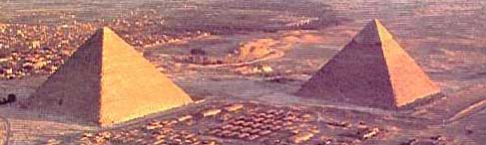  a pyramid with a flat top on the left and a pyramid with a pointed top on the right. | a freemason symbol
Once again compare the Great Pyramid on the left with the Great Pyramid on the right.
The Great Pyramid is flat at the top, so you can see that there is no stone around the corner of the head.
Also, the figure on the right is a symbol of Freemasonry, which means that Satan will sit on top of the pyramid instead of Jesus.
The all seeing eye symbolizes Horus with the head of a hawk, and Horus symbolizes Satan.
Satan is now trying to use the Freemason organization to establish a world government, and when the world government is established, everyone will worship the Antichrist(World Government Leader).

The Great Pyramid symbolize the kingdom of heaven and at the same time represents the history of God's salvation.
It's downhill from the entrance to the basement.
A person who does not believe in God means going to hell, the basement, and there is a trap in the basement, so you can not come out once you enter.
There is only a dead end to go further in the basement.
From the entrance to the way up and the intersection, it indicates from the Genesis to the moses.
Moses appeared with the law, and was able to open the path of salvation (open the stone cover) and climb up.
However, the way down is wide, but the way up is narrow.
Matt.7:13~14 "Enter by the narrow gate; for wide is the gate and broad is the way that leads to destruction, and there are many who go in by it..
"Because narrow is the gate and difficult is the way which leads to life, and there are few who find it.
The road to hell is wide and downhill, so many people go, and the road to heaven is a narrow uphill, so few people go.
It is easy to live materially and evil in the world but it is difficult to live holy and good.
However, in the Old Testament period, the place where Moses' law is kept is not heaven but underground paradise.
The underground paradise is the queen's room, and the underground paradise is explained in detail in the 'Heaven and Hell' section.
In the New Testament era, anyone who believe in Jesus can enter the heaven, king's room.
However, if you do not believe in Jesus in the New Testament era, you will go to hell through a shortcut to the basement.
The New Testament era has a certain length of grand gallery, and Jesus will come and rule when the New Testament era is over.
The sarcophagus in the king's room is consistent with the appearance of the ark of the covenant, and the place where the ark of the covenant is the place where God presence.

