Freemason (Symbol)

Freemasons have many symbols that represent their ideas.
1. Compass and Square Measure
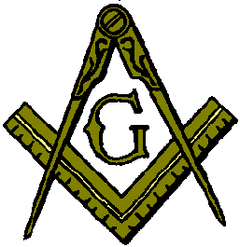 | 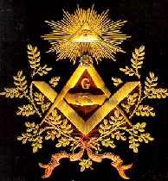
A representative symbol of Freemasonry is Compass and Square Measure, a must for masonry.
The compass can draw a circle, and the circle symbolizes perfection.
The Square Measure can measure the horizontal and verticality of the building, and it is the basic tool of architecture.
The right angle is the standard composition of all buildings, and the horizontal and vertical meet to achieve accuracy.
'G' stands for 'Gimel' in Hebrew, and Gimel has the meaning of 'one'.
The compass represents a man(the Sun god Ra) and the Square Measure represents a woman(Isis).
The one-eyed figure on the righ,t symbolizes the Egyptian Horus god.

2. Pyramid
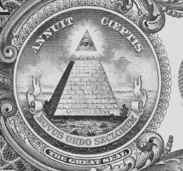 | It is evidence of Egyptian faith that the pyramid behind the 1 Dollar bill.  If you interpret the letter, the above 'ANNUIT COEPTIS' means 'God takes care of what we do'.  The 'NOVUS ORDO SECLORUM' is 'the New World Order'. which is the founding ideology of Illuminati.  The all seeing eye, which shines at the top of the pyramid, means that the Illuminati dominates the world, and specifically indicates that the world government is established and "one-person dictatorship"(Satanic rule).
It is written in the pyramid MDCCLXXVI, which is Roma number 1776.
1776 was the year when Illuminati formally founded at the same time that the United States was independant.
The pyramid is 13th floor and represents the number 13 that Freemason's most sacred.
At the top of the paramid, 'the all seeing eye'(the third eye) triangle shines.
The third eye is a jeweled part of the Buddha's forehead, which means that a person realizes the truth through the forebrain.
The top of the pyramid represents a spiritual place, and the omnipotent god controls all classes.
The glow of the eye means the shine of the saint, and the state of truth and power is full.
'The all seeing eye' symbolizes the "World Government Leader" (the Antichrist in the Revelation) who will rule the world in the future, and he will takethe power of Satan and perform a tremendous miracle and deceit people.

3. Phoenix
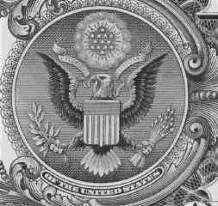 | 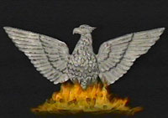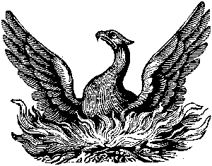 | 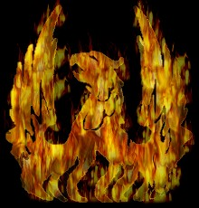
The eagle behind the Dala $1 bill is the symbol of the US government and the insignia of the president.
Originally, Freemasons tried to put the Phoenix in Egyptian mythology, but when the rejection was severe, they painted an eagle instead.
The Phoenix is a legendary bird that survives in fire once a millennium.
The right wing of the eagle has 32 feathers, 33 on the left, 32 means wise way, and 33 refers to the 33rd grade of the Scottish rite.
There are 13 stars above the eagle head, and 13 leafs and arrows on both feet.
13 is a sacred number of Freemasons, but they propagandize that 13 is ominous number so that ordinary people do not know.
13 means transcendental number by adding 1 to 12 which means completion.
Add the face and line of the pyramid is 5+8=13.
The ribbon that the eagle bites says 'E PLURIBUS UNUM', which means that many people are united one.
This means that when the world government is established, people lives like a slave under a dictator.

4. Obelisk
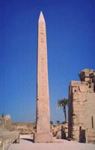 | 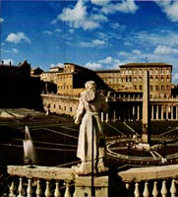 | 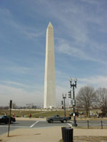
The one on the left is the obelisk in the Egyptian temple, the center is the obelisk in the Vatican, and the right is the Washington Monument.
Obelisk is exist in famous cities all over the world, and the origin is Egypt.
The obelisk is derived from Egyptian mythology, which means the penis of IOsiris(isis' husband).
The obelisk of the Vatican Square indicates that Catholicism inherited the Egyptian faith.
Ancient faith has the belief that men and women are united and that they become perfect when they perform sexual acts, so they sex with the priesthood were officially performed in the temple.

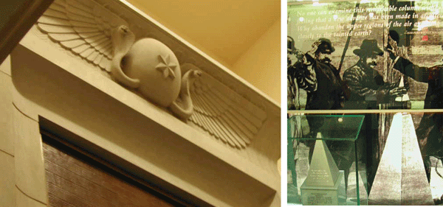
The picture above is an inside photo of the Washington Memorial Tower, with snakes, star and wings on the elevator, and history and photos related to obelisk on the rooftop observatory.

5. 자유의 여신상
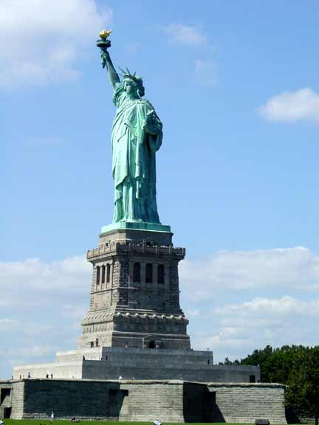 | 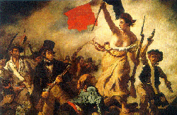 | 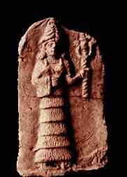

The Statue of Liberty was created in France to celebrate the centenary of the founding of the United States, and the design was made by Bartoli, a 33-degree Freemason in France.
The figure on the right is a p goddess holding a torch of Babylon.
The torch means the truth that Prometheus stole from God, and it is the ideology of Illuminati that the person can be a god.
In the left hand of the statue is a slate of the Declaration of Independence, carved July 4, 1776.

6. Road of Washington D,C.
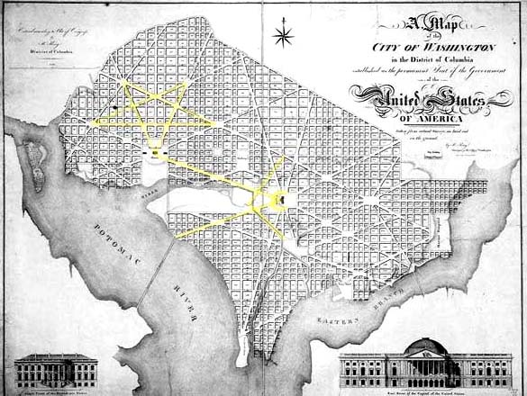
It's a map showing the Washington city road in the U.S.
George Washington entrusts the design of Washington, D.C. to the French Freemason architect Pierre Charles L Enfant.
You can see the upside down five-angle stars and compass, marked in yellow in map.
Both the Five-angle stgar and the Compass are the main symbols of Freemasonry.

7. Five-angle stgar
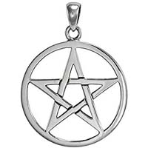 | 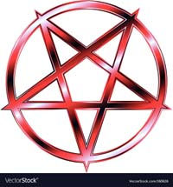 | 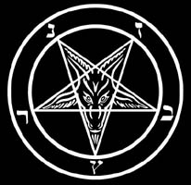
In Freemasonry and Occult magic, they use five-angle star as symbols.
The five-angle star used in magic, and the upside down five-angle star is used in Satanism.
The goat-like Baformet is the main symbol of the Church of Satan and the Satanist.

8. Pentagon
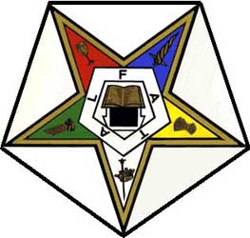 | 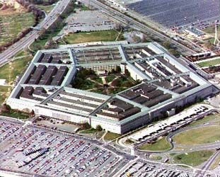
The pentagon is also a major symbol of Freemasonry.
The Pentagon has a five-angle shape throughout the building.
The senior U.S.Defense Department official is closely related to the military-industrial complex, and many are Freemasons.
The Greek Pythagorean school thought that 5 was a combination of male number 3 and female number 2.
The Pythagorean school used 5 as a symbol to indicate that 5-angle star is member of the Pythagorean party.
The left figure is a symbol of a Freemason group called 'Star of the East', which is made up of women founded in 1850.

9. two pillars
The two pillars are related to the Hiram Sharif of the Kingdom of Tyre, the original mason.
He made severa brassl holy objects of temple of Israel.
Among them, two brass pillars called Boas and Yakin are famous, and Freemason is using them as symbols.

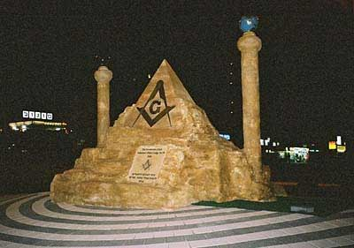
Mason-Pyramid and Two Columns on the streets of Israel

