Mesopotamian Civilization
The four ancient civilizations are Mesopotamian civilization, Egyptian civilization, Indus civilization, and Yellow River civilization.
Among them, Mesopotamian civilization is the oldest, and it is the foundation of other civilizations.
The civilization of Mesopotamia began with the Sumerian civilization.
After the Sumerian civilization, Babylon was born, Babylon was destroyed by Assirah, and Assirah was destroyed by the new Babylon, new Babylon was destroyed by Persia, and finally the Persian was destroyed by Magedonia, so Mesopotamian civilization is ended
Babylon is now the Iraqi region, an empire that once rule the Middle East.
Babylon is the kingdom of Satan, with all seven elements of worship of Satan, and a nation that symbolizes evil.
The new Babylon destroyed South Judas and brought Jews to captivity.
1. Mesopotamian civilization

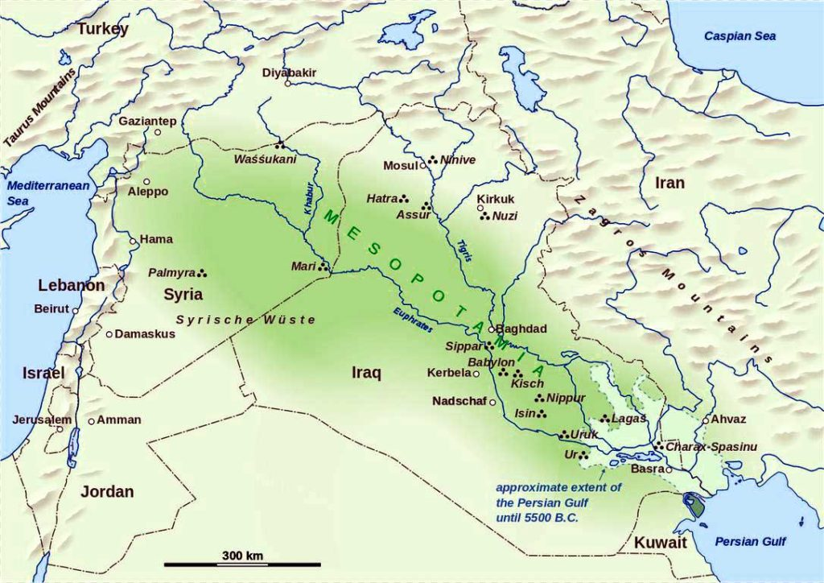

Mesopotamian civilization refers to the civilization that took place in Mesopotamia.
Mesopotamia means the land between the two rivers, which means the fertile half-moon land between Tigris River and the Euphrates River.
Unlike closed Egyptian civilization, the regions between two river were always invaded by ethnic nations, and the culture developed in this area was open because of the rise and fall of the nations and the frequent replacement of the people.
1. The Sumerian city-state (30000 BC);
The Sumerians lived in the eastern mountainous region of the fertile crescent area and moved to southern Mesopotamia.
They had been in a civilisational phase to some extent since they were originally in their residence.
In the southern part of Mesopotamia, civilizations that use metal and stone together were considerably developed around areas such as Alubaid and Urq.
It was around the year B.C3000 that the Sumerians appeared.
Politics - The king became the best priest as a proxy for God, and the politics of the priesthood was carried out.
Priest, bureaucrats, warriors, etc. were the dominant classes.
A temple with a large tower called Ziggurat became the center of the state.
Economics - As trade took place, merchants also appeared.
Code - The Sumerian law, the world's best written law, was unearthed in 1947.
2. The Akkad dynasty (2300 BC);
The Akkadians(the Semitics) lived around the Sumerians, based on Ur.
Around 2350 B.C., Akadian conquered the Sumerians and established the first unified kingdom, but it did not last long.
3. The Old Babylon, Amur period (BC 1800);
The Amurs reunited the area, set up a capital in Babylon, and built the Babylonian kingdom.
Hammurabi the Great conquered Mesopotamia around the 18th century B.C. and compiled the "Code of Hammurabi" to establish a centralized regime.

4. Invasion of Indian-European (B.C. 1550);
In the 16th century B.C., the first Iron Age user of Orient, the Hittite invaded and threatened the Babylonian kingdom, and ruled Babylonia.
5. Unification of Assyria (BC 689);
After that, the region continued to divide and confuse for a long time and was unified by Assyria.
North Israel was destroyed by Assyria in 722 B.C.
6. Reunification of Babylon, the New Babylon Empire (BC 612);
King Nebuchadnezzar of Babylon conquered the capital of Assyria in 612 B.C.
In 586 B.C. South Judas was occupied by Babylon, and many people were taken prisoner.
7. Persian empire (B.C. 539);
The Allied forces of Persia and Midia conquered Babylon in 539 B.C.
Under the permission of King Gores of Persia, the Jews return to Jerusalem in 538 B.C.
8. Conquest of Babylon by Alexander the Great (B.C. 331);
Persia of Darius III is destroyed by Alexander the Great of Macedonia, who unified Greece.
Since then, Hela culture had flowed in and Islamic culture had formed, losing the characteristics of Mesopotamian culture.

2. The Sumer (B.C. 3000)
The Sumerians built the first city and school.
In the city, politics, economy, military, and life are all centered on temples, so it was called temple countries.
They usedthe 'duodecimal system' and 'the lunar calendar', and They also created a code called the Sumerian law.
The Sumerian language is 'agglutinating language' that attaches 'postpositional particle' to noun.
The 'agglutinating language' is a feature of the 'Ural Altai language', and it belongs to Turkey, Mongolia, Korea and Japan.
The Sumerians sacrificed to god in a circular high-rise temple called Ziggurat, similar to the Babel Tower in the Bible.
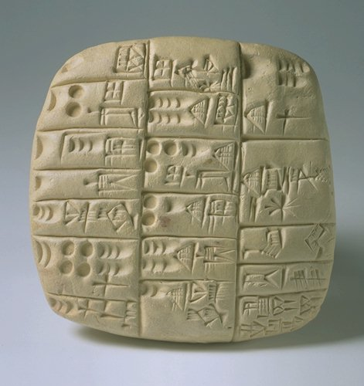
Sumer used letters for the first time in mankind.
At first it was a hieroglyphic character that mimics the shape of an object, later became 'cuneiform script' that represented the meaning as a wedge-shaped sign.
The Sumerians wrote letters by scraping clay with a reed pen on dried clay.

* Sumerian god
There are thousands of gods of Sumerian, and only changed names, serving in Babylon.
(in parentheses, later names)
The three gods of Sumer are An, Enki, and Enril.
Please note that bulls, eagles, lions, goats, half-human half-beast, dragons, snakes, and sun gods symbolize Satan.
Fish, horses, etc.are also symbols of demons.
a) An (anu)
Father of all gods, father of all evil spirits.
It has a headdress with horns and is represented by a large bull.
b) Enril (Marduk, Bell)
It is the god of wind as a child born by marrying heaven god Ahn and Ki, the goddess of the earth,
Marduk was also called the master, the god of lightning and the national god of Babylon.
It was the best god with 50 names during the reign of Nebuchadnezzar I of New Babylon, and there was a Maruduk temple shrine at the top of the zigurat.
Maruduk's star is Jupiter and his holy animal is a dragon with horses, dogs and cracked tongues.
He rides in a carriage, has stars in his jacket, holds scepter in his hands, and carries lightning.
In Phoenicia, it was served as Baalsin, and Jews were judged many times for believing in Baal.
Satan likes to be called the son of the creator, and if he has a dragon shape and scepter, he can be called Satan.
It is similar to Greek Zeus to carry lightning.
c) Nki (Ea)
He created a man who was a slave to the gods with the god of water and wisdom born between the heavenly god An and the underground goddess Nammu.
It is the shape of half-chlorine half-fish and controls magic and spells.

d) Isuecur
It is a god who controls rain and thunderstorms and is expressed as a big bull.
It has lightning and tridents.
Having a trident is like Poseidon in Greek mythology.
e) Adad
He is in charge of the weather and manages rain and typhoons.
To him, six is a sacred number, receiving bulls and lions as sacrifices.
f) Shamashi
The sun god is the god of justice and fairness.
King Hammurabi of Babylon is said to have received a code from him.
He has a cane and a ring, sits on the throne, and acts as a visionary.
g) Nergal
God of earth and war, God of plague, hunger and destruction.
It resembles Shiva, the god of Hindu fear and destruction.
h) Nanna (God)
The symbol is the crescent moon as the god of the moon.
It is described as an old man with four horns and a beard.

i) Inanna (Ishtar)
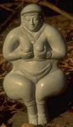 | 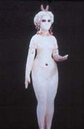 | 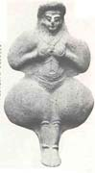
On the left side of the picture is Sumerian goddess Inanna, on the middle is Inanna in the Ur region, and on the right is Babylon goddess Ishtar.
Inanna is the daughter of the moon god Nanna, the goddess of war and sexuality.
It is a goddess of jealousy, a goddess of fertility, and a goddess who enjoys physical love.
It is also the goddess of death and disaster. It has duality and symbolizes 6,8,16 rays star in the circle.
Eirek, the cult of Ishtar, was a city full of prostitutes.
They sacred sex and sacred to enjoy sex with the priesthood in the temple.
Greece and Rome were also influenced by this, and they naturally engaged in free sex and group sex.
At that time, people thought that if this goddess was excited and sweating, it would rain a lot and farming would be good, and they became official prostitution.
Ishtar went to Phoenicia and Greece and became Aphrodite.
She went to Rome and became Venus and became a goddess of sensuality.

3. The Akkad dynasty (Semitics) (B.C. 2300)
The Semitics flourished with the Sumerians around the Ur region.
The Semitics are nomadic people and are ancestors of Jews and Arabs.
Gen.15:6~7 And he believed in the LORD, and He accounted it to him for righteousness.
Then He said to him, "I am the LORD, who brought you out of Ur of the Chaldeans, to give you this land to inherit it."
The Ur region is a place to serve idols, and God could not active on Abraham there.
Therefore, Abraham in the Ur region is called by God, and he moves to the Canaan land with his family and nephew Lot and becomes the ancestor of the Jews.
From the 19th century, the Ur region was excavated and it was discovered that they were forming civilization.
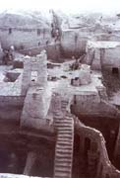 | 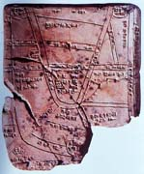 | 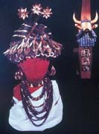

The left side of the picture of the city of Ur, the middle is a clay plate map, and the right is a metal craft.
Ur had a precise waterway, complete with water and sewage facilities, and thousands of rooms.
The Semitic conquered the Sumerian city state in 2300 B.C.and established the first unified kingdom.

4. Babylon (B.C. 1800)
The Amurs reunited the area, set up a capital in Babylon, and built the Babylonian kingdom.
a) The Code of Hammurabi;
Hammurabi the Great conquered Mesopotamia around the 18th century B.C. and compiled the "The Code of Hammurabi" to establish a centralized regime.
The Code o Hammurabi Code is written as the inspiration of Satan because it is announced that the king received it from the sun god.
b) Gilgamesh epic
Gilgamesh epic is the world's first epic, and Gilgamesh showed himself as a human being who refuses to die.
Gilgamesh epics also affect Greek Ilyads and Odysseys.
It was originally made in the Sumerian period, but it was completed in the Babylonian era.
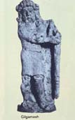 | 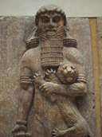
The above picture is King Gilgamesh, who ruled the city of Sumerian, holding a lion with his left hand.
This epic has also influenced heroic stories like Helacles and has a New Age idea of superman.

5. Assyria (B.C. 960)
a) History
Assyria is a city-state, It existed around B.C. 2300, was located in the upper Tigris River, mostly of the Semitic, and lived around Nineveh Castle.
The ancestor of Assyria is Asshur, son of Sem, son of Noah.
For 350 years from 960 AD, Assyria was the first to form an empire in the world.

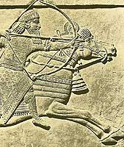 | 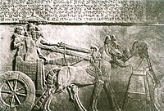 | 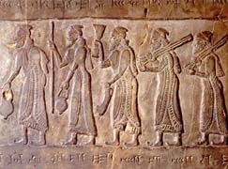

The le`ft picture is an Assyrian soldier, the middle is a procession of kings; the right is tributes to the Assyrian king.
Salmaneser V (727-722 BC): When Egypt enticed Josea of Northern Israel to rebel against Assyria, after three years of siege of Samaria, Assyria destroying North Israel in 722 BC.
Sancherib (705-681 BC) was the son of Sargon II, who ruthlessly dealt with treason in various places, trampling Babylon Castle in 689 BC.
In 701 BC, he attacked many cities of Judah to punish the king of Judah who led the rebellion.
Later, Sanherip re-invaded Judah, approached Jerusalem, but lost 185,000 soldiers a night due to the faith of Hisgiah and the intervention of God.
He was then killed by his sons in his home country.
In 612, BC the capital Ninebe was surrounded by Babylon and Midia and Scythians for three months. It fell at the end.

b) Culture
Nineveh, which became the capital of Assyria in 700 B.C. emerged as the greatest city by that time.
Ninewe Castle once had the prophet Jonah repent at God's orders to avoid judgment.
The walls surrounding the magnificent palace and temples were thick enough to run three carts (9.6m wide), and 23m tall walls were surrounded by moats(defensive ponds) with a width of 24m.
Nineveh, which flourished many merchants was the center of the world like Rome but brutal.
The king, who is more cruel than Ashrnassirpal who poked the prisoners and betraitors on spears and skinned them, is Sennacherib, who moved the capital to Nineveh.
He killed the residents one by one and burned the houses until the whole city was full of bodies when he hit Babylon.
This blood king was praying at the temple of Nineveh, and was killed by his sons and his body was also stained with blood.
They refine the stones, set up arches, dug waterways, and left outstanding sculpture art in later generations.
The library was filled with books of mathematics, astronomy, and astrology, and for the first time in the world, it had botanical gardens, zoos and hunting grounds.
The Assyrian army organization had cavalry, heavy infantry, artillery, and intelligence.
The Old Testament called the Assyrian army 'like a storm'.
The prophet Isaiah said, "They roared like a lion, leaving sadness and darkness wherever they passed."
Assyria, which swept West Asia like gust, disappeared like smoke in 612 BC.
King Ashrebanipal, who was in luxury and laziness, set fire to the palace when the media, Caldea, and Scythian coalitions came.
The most dazzling and huge city on earth, Nineveh, had been turned into ruins.
Nah.3:7 It shall come to pass that all who look upon you Will flee from you, and say, 'Nineveh is laid waste! Who will bemoan her?' Where shall I seek comforters for you?"

c) Religion
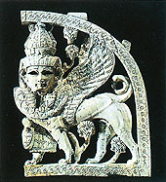 | 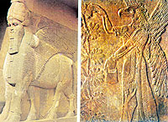 | 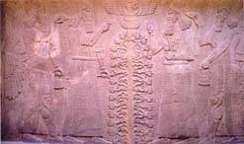

The left picture is a lion with wings on a person's face, mid is five legs on a person's face, a winged bull and a vulture-faced Cherubim guarding the life tree, and the right is the gods guarding the life tree.
This is also found in Sumer and Babylon, Assyria also has a religion that serves Satan.
Ashur, the national god of Assyria, was appointed king of the gods, and They served the moon, the sun, and the goddess of love.
There were temples in each city, and there was a guardian god.
The Assyrians took the spiritual world seriously and offered sacrifices for the dead.

d) Relics
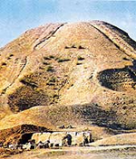 | 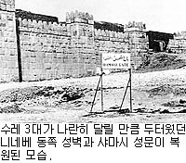 | 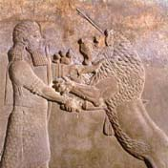
The left photo is a sandy Nineveh site, a restored Nineveh wall in the middle, and the right is the king of Ashurbanipal who kills the lion.
In 1840, relics are revealed as they dig up a hill presumed to be Nineveh, the capital of Assyria.
Lion with wings on the body, a eagle head with winged god came out, and They worshiped it as a god.
There were 2500 clay tablets inscribed with wedge letters in the library, which included writings on philosophy, astronomy, mathematics, medicine, and literature.

6. New Babylon (B.C. 605)
a) History
In world history, it generally separates two Babylonians:
That is, the former Babylonia, the first dynasty of Babylon that lasted for three centuries from 1830 B.C. to 1531 B.C. and then, a thousand years later, less than 80 years in the same place (B.C. 605-530) is Nebchatnezzar's New Babylon

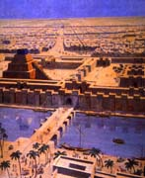 | 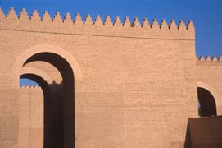 | 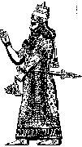

Even after the First Dynasty collapsed, Babylon continued to be a center of culture and religion in the ancient world, and at the time of the Assyrian Empire, it became a servant kingdom.
However, due to continued treason, Sanherip in Assyria tried to completely destroy Babylon in 689 BC, but it was rebuilt soon after because of its importance.
Then by 626 BC, King Nabophoratsal of Babylon finally declared independence and began war with Assyria, allied with Media, and with the support of Scidia, succeeded in knocking over Assyria by taking down Nineveh in 612 BC.
Here is a summary of the Babylonian kings and history
* Nebuchadnezzar II (B.C.605–562): The most outstanding king who made New Babylonia the great empire, defeating Egypt in the Battle of Kalkemisch, conquering Palestine, including Syria and Judah, and reaching the border with Egypt.
During the first conquest of Palestine in 605, he took Daniel and three other friends as pawns, and in 597 BC he captured ten thousand people. In 586 BC he captured blind Sidgaya and numerous prisoners and destroyed the temples and walls of Jerusalem.
* Belshazzar B.C. 553-539) is the last king of New Babylon.
He was killed by King Gores of Persia, who was crowned around 553 BC and invaded in 539 BC.
And Babylon was destroyed forever.

b) Culture
Babylon Castle is a double castle, 3.7 meters height and 6.5 meters thick, with a huge rectangular shape of 1,800 meters and 1,300 meters on both sides.
Among the eight great gates, the Ishtar gate, which was built for Babylon's god Maruuk, is the most famous.
On the way through the gate, the shapes of glazed bulls(bel) and dragons(Marduk) line up:
The walls are made of brick with blue glaze, which is sculptured lions(symbols of the Ishtar)

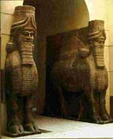 | 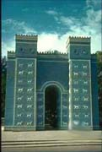 | 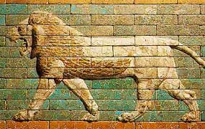

At that time, Babylon had 53 temples for the great gods, 55 temples for the Marduk, 300 temples for the gods of the earth, 600 tenples for the gods of the heavens, and 400 altars for various gods.
Among them was a zigarat, which means "the door of God."
It was seven stories high, 90 meters high and used 85 million bricks.
Babylon was left devastated for nearly 2,000 years, and it was excavated by the German Coldeby from 1899 to 1917.
Babylon has many pictures and sculptures of lions because they identify the goddess Ishtar.

7. Persia (B.C. 539-331)
a) History
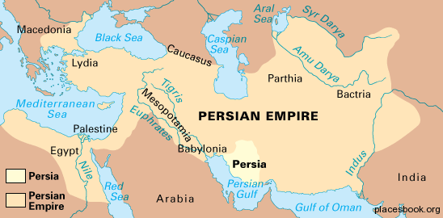
Persians are nomads who have moved from southern Russia to the Iranian region since 1000 B.C.
In 549 BC, Cyrus the Great of Persia, who annexed Media (Turkey), built the empire.
He made Greek city states a tributary, and by 539 BC he captured Babylon, known as the "biggest city in the world".
The Persian army changed the flow of the Euphrades River and entered Babylon Castle along the dry river floor.
He returned the Jewish people detained in Babylon after the conquest of Babylon to the israel, and helped the Jews restore the temple of Jerusalem that Babylon destroyed.
Cyrus adored many conquerors gods, including the Babylonian god Marduk.
He was on an expedition to the East, and eventually he was killed in battle with a nomadic tribe.
Egypt was also subjugated to the Persian Empire by Cambyses II, the son of Cyrus.
Persia had conquered all of the great powers around Lydia, Babylon and Egypt.
The decline of this Persian empire came from the end of the 5th century BC when the Greek expedition was failed.
In 490 BC, the Greek coalition centered on Athens defeated the Persian army in the marathon plain.
Darius I died in preparation for a Greek re-invasion after retreating.
After Darius, Xerxes I led the large army back to Greece.
However, in the Battle of Salamis, the Persian Navy was deeated by the Greek Allies.
This weakened Persian power, and Greek city states gained power.
In 334 BC, Persia, ruled by Darius III, collapsed in the attack of Alexander the Great of Macedonia, who unified the Greek world.
The Persian Empire is closed after Darius III was assassinated by his servants.

b) Culture
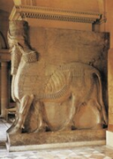 | 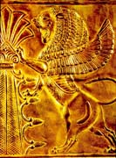 | 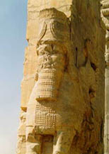
Persians were culturally forming an Orient culture similar to Assyria and Babylon, and the political system(monarchy) was different from Greece(republic).
The Persian Empire developed various cultures by respecting and accepting the culture of conquered countries.
Darius I introduced the currency and postal system, and uses Aramaic as the diplomatic language of the empire.
There were 2,698 kilometer long King's Road and due to the rapid change of horses station, urgent documents could reach within a week.

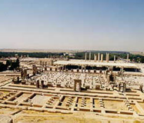 | 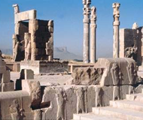 | 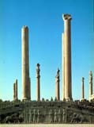
Darius builds a new capital in Persepolis.
When you climb the stairs, there is a 'Door of all nations' entering the palace.
Every year, the envoys who came to pay tribute to the Persian Empire entered the main palace through this door.
Alexander destroys this place thoroughly because Persepolis is the key point of his most powerful rival, Persia, after defeating Darius in 331.

c) Religion
In religion, while the surrounding Orient countries and Greece adopted polytheism, Persia adopted monotheism similar to Judaism.
The national religion of Persia is Zoroastrianism founded by Zoroastrian(Charathustra) around the 6th and 7th centuries BC.
The Iranian people were originally polytheistic, similar to the surrounding people, but they were transformed into monotheism by the reform of Zoroastrianism.
Zoroastrianism is a dualistic monotheism that Ahura Mazda, the god of good and light, confronts Ariman, the god of evil and darkness, and finally wins, and worships Ahura Mazda and his symbol, Fire.
However, Zoroastrianism was popular in Iran until the emergence of Islam in Persia, but it did not affect other countries.
On the other hand, the sects of Mithraism, Manichaeism, which were called Zoroastrian heresy, affect many peoples outside the Iran.
Mithraism was welcomed by soldiers especially in the Roman Empire, and it spread widely to the UK to find traces of Mithra temples.
Before Christianity is introduced, Satan again creates Zoroastrianism similar to Christianity, which confuses people.
Zoroastko is the intention of Satan to stand in the god of good, with the fact that the god of good and evil fights and the god of good wins.
It makes the salvation and resurrection of the soul, the end of the world and the judgment similar, and the people of Rome and Europe are beguiling but lost to Christianity.
However, the mystical tradition of Manichaean and Mithraism has been inherited by Freemasons.
Manichaean emphasis on light is similar to Illuminati's thought.
Persia is the country that corresponds to the silver breast and arm of Daniel's idol.
The Middle East, which believed in polytheistic worship and dualist Zoroastrianism, is eventually absorbed into Islam, similar to the Judaism founded by Mahomed.
Satan creates a religion similar to the Bible from beginning to end, and disturbs the history of God.

