Satan and Demons

 | 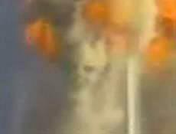 | 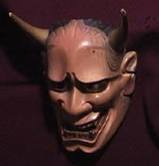
The left and center of the picture above are the demons that appeared at the time of the 9/11 terrorist attacks, and the right is the traditional mask called Hannya of Japan, which resembles the demon.
Both photos are almost similar in face shape, head, eyes, nose, jaws, and so on, and they are typical demon shape.
The demon originally wants to show off his presence, so he appears at the sites of disasters such as the Trade Center, Chicago, and WACO below.
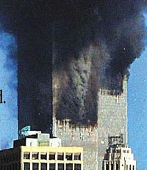 | 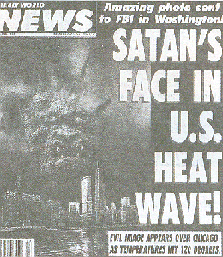 | 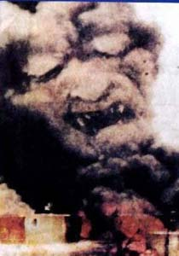

Satan was a special being called Cherubim, who was full of wisdom and ability in the heaven, but became arrogant and was driven to the ground by crime against God.
The countless angels who followed him also rebelled and were judged for crime, becoming an ugly demons.
Satan has been interfering with the history of God, and intends to construct his kingdom by polluting this land with sin and corruption.

* Table of Contents
1. The origim of Satan
2. Cherubim
3. the appearance of Satan
4. The shape of Demons
5. Personality of Satan and devils
6. Satan as shown in the Bible
7. The master of imitation, Satan
8. Satan who possess and controls the world
9. Satan can possess the person who is not born again
10. 15 elements that may be affected by Satan
11. Conclusion

1. The origim of Satan
Ezek.28:11~19 Moreover the word of the LORD came unto me, saying,
Son of man, take up a lamentation upon the king of Tyrus, and say unto him, Thus saith the Lord GOD; Thou sealest up the sum, full of wisdom, and perfect in beauty.
Thou hast been in Eden the garden of God; every precious stone [was] thy covering, the sardius, topaz, and the diamond, the beryl, the onyx, and the jasper, the sapphire, the emerald, and the carbuncle, and gold: the workmanship of thy tabrets and of thy pipes was prepared in thee in the day that thou wast created.
Thou [art] the anointed cherub that covereth; and I have set thee [so]: thou wast upon the holy mountain of God; thou hast walked up and down in the midst of the stones of fire.
Thou [wast] perfect in thy ways from the day that thou wast created, till iniquity was found in thee.
By the multitude of thy merchandise they have filled the midst of thee with violence, and thou hast sinned: therefore I will cast thee as profane out of the mountain of God: and I will destroy thee, O covering cherub, from the midst of the stones of fire.
Thine heart was lifted up because of thy beauty, thou hast corrupted thy wisdom by reason of thy brightness: I will cast thee to the ground, I will lay thee before kings, that they may behold thee.
Thou hast defiled thy sanctuaries by the multitude of thine iniquities, by the iniquity of thy traffick; therefore will I bring forth a fire from the midst of thee, it shall devour thee, and I will bring thee to ashes upon the earth in the sight of all them that behold thee.
All they that know thee among the people shall be astonished at thee: thou shalt be a terror, and never [shalt] thou [be] any more.
The above article is the word of God about the king of Tyrus and Satan.
The Kingdom of Tyrus means Phoenicia, a country that has developed the culture of Egypt and Babylon and passed it to Greece, and is the country where the father of Freemason, Hiram Sharif, had lived.
The Kingdom of Tyrus was a country that symbolized Satan, which created Baal, worshiped the goddess, and killed many children by practicing human sacrifices, so God tied it together.
Satan was originally a winged Cherubim, a special being, unlike ordinary angels.
Satan was born as a beautiful perfect being in the heaven, wisdom and ability were outstanding.
The fact that he received oil anointment means that he was king or priest.
Cherubims covers the sanctuary of God with their wings, which can be found in the ark of the covenant.
The Garden of God, Eden is not the Eden of Adam's time, but the garden of heaven.
When Satan was created, God was delighted and wrapped him in various jewels, and let angels play for him.
However, Satan managed the wealth of the heaven and he became greedy and took it in unjust way.
Satan, who has dirty the heavenly sanctuary with the sin of the transaction, was judged by God and was driven to the ground and falls down.

Is.14:12~15 How art thou fallen from heaven, O Lucifer, son of the morning! [how] art thou cut down to the ground, which didst weaken the nations!
For thou hast said in thine heart, I will ascend into heaven, I will exalt my throne above the stars of God: I will sit also upon the mount of the congregation, in the sides of the north:
I will ascend above the heights of the clouds; I will be like the most High.
Yet thou shalt be brought down to hell, to the sides of the pit.
Satan also appears in Isaiah, whose original name is Lucifer, son of the morning.
Satan, who had excellent wisdom and ability, had a proud heart and coveted the place of God.
So he instigated angels under his command and tried to rebel against God.
But how will the creature fight the Creator and win?
Satan and demons were defeated and kicked out of heaven, and they have lived on earth and hell.

2. Cherubim
Let's take a closer look at Cherubim, who was before Satan fell.
Ezek.1:5 Also out of the midst thereof [came] the likeness of four living creatures. And this [was] their appearance; they had the likeness of a man.
And every one had four faces, and every one had four wings.
And their feet [were] straight feet; and the sole of their feet [was] like the sole of a calf's foot: and they sparkled like the colour of burnished brass.
And [they had] the hands of a man under their wings on their four sides; and they four had their faces and their wings.
Their wings [were] joined one to another; they turned not when they went; they went every one straight forward.
As for the likeness of their faces, they four had the face of a man, and the face of a lion, on the right side: and they four had the face of an ox on the left side; they four also had the face of an eagle.
The proohet Ezekiel of Israel sees the shapes of four 'living creatures'(Cherubims) and God before receiving revelation.
Cherubim lives in the closest corner of God, becomes the chief of all angels, and possesses tremendous ability.
Kerubim defends the tree of life, covers the sanctuary of heaven, escorts and praises God.
The four creatures have strange shapes, similar in human shape, but with two pairs of wings, each with a hand under the wing, with a total of 4 wings and 4 hands.
The feet are straight like columns, have calf soles, and shine in the same color as brass.
The four wings of the four creatures are in contact with each other, and when they move, they do not turn and go straight forward.
Four creatures have four heads, each with a different shape of face in four directions.
The front is the face of a person, the right side has the face of a lion, the left side has the face of a cow, and the back side has the face of an eagle.
Also, two of the four wings are stretched upwards and touching each other, and the other two wings are covered body and touching downward.

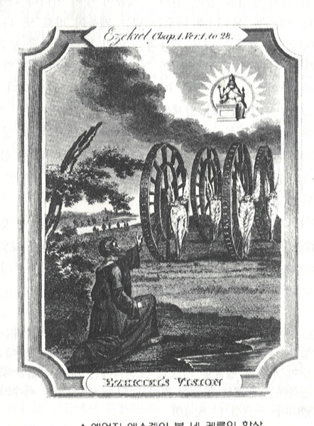
God and 4 livintg reatures

Ezek.1:15~21 Now as I beheld the living creatures, behold one wheel upon the earth by the living creatures, with his four faces.
The appearance of the wheels and their work [was] like unto the colour of a beryl: and they four had one likeness: and their appearance and their work [was] as it were a wheel in the middle of a wheel.
When they went, they went upon their four sides: [and] they turned not when they went.
As for their rings, they were so high that they were dreadful; and their rings [were] full of eyes round about them four.
And when the living creatures went, the wheels went by them: and when the living creatures were lifted up from the earth, the wheels were lifted up.
Whithersoever the spirit was to go, they went, thither [was their] spirit to go; and the wheels were lifted up over against them: for the spirit of the living creature [was] in the wheels.
When those went, [these] went; and when those stood, [these] stood; and when those were lifted up from the earth, the wheels were lifted up over against them: for the spirit of the living creature [was] in the wheels.
Ezekiel saw them and there was a big wheel on the ground next to them.
The color of the wheel is a beryl, the structure seems to have another wheel in the wheel, and the circumference of the wheel is very high.
When living creatures move, the wheels do not rotate, but they go 4 sides, and the wheels are full of eyes.
When the creature moves, the wheels are always go together, and the spirit of the living creature is in the wheel.
Wherever the spirit wants to go, the living creatures and the wheels are lifted up from the earth together.
This explains how the four livig creatures can go all over the place without turning around.
Rev.4:6~8 And before the throne [there was] a sea of glass like unto crystal: and in the midst of the throne, and round about the throne, [were] four beasts full of eyes before and behind.
And the first beast [was] like a lion, and the second beast like a calf, and the third beast had a face as a man, and the fourth beast [was] like a flying eagle.
And the four beasts had each of them six wings about [him]; and [they were] full of eyes within: and they rest not day and night, saying, Holy, holy, holy, Lord God Almighty, which was, and is, and is to come.
In the New Testament era, John the Apostle went up to heaven and saw four creatures by God, similar to before, but different.
1. One creature did not have four faces, but four creatures were different.
2. Two more wings have been increased from four to six.
3. The wheels around Kerubim have been removed.
4. The eyes on the wheels moved into the wings.
This seems to have merged the Keroubeam and the wheel, and the increase in the wings adds to the ability, and the four faces are one and different, so it can be seen that they have changed into different individualities.

3. the appearance of Satan
Satan has been served as a god by people since ancient times.
Since God only active on Jews in the Old Testament, all other ancient civilizations have to do with Satan.
Satan once appeared in the form of Cherubim.
It appeared in the shape of four faces of Cherubim: cow, eagle(hawk), lion, and human.
Goats are also a representative symbol of Satan, because Goats are belonging to the bovine family.
Gen.3:14 And the LORD God said unto the serpent, Because thou hast done this, thou [art] cursed above all cattle, and above every beast of the field; upon thy belly shalt thou go, and dust shalt thou eat all the days of thy life:
In addition, it appears in the form of a snake, because Satan, who was cursed by God, also became a snake.
Half-man, several arms, several faces, winged person, and eye-shaped gods match the appearance of Cherubim.
In ancient faith, there are many gods, but the god who looked above has always been the best god.
Satan also liked to be served as the son of the Creator or as the Sun god.
a) Cow
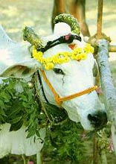 | The most severe place for cattle worship is India, which believes in Hinduism.  They don't eat beef. evven though many people are starving.  There are so many cows in the city, traffic jam happens..  Hindus serve cattle as gods, not animals.  Indians think that God lives in every part of the cow, and even the milk, shit and urine of the cow are sacred.  There are about 200 million cows in India, the world's largest.  The next picture is a cow decorated for a cattle worship ritual in India.
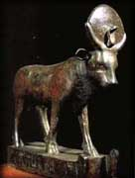 | The statue of the bull is the Horus, god of Egypt, with the sun and snake above his head.  The Horus, Egypt's best god, is a bull at the same time a hawk.
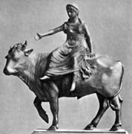 | The left photo is the Phoenician god Zeus(the bull) and Europa, who climbed on it.  According to Phoenician mythology, the god Zeus turned into a bull and approached Europa, where Europa climbed on his back, and the bull swam the sea and crossed into Crete.  This symbolizes the spread of civilizations in Phoenicia to Greece and Rome, and Europe is born after Europa.  Zeus is worshipped as the best god in Greek mythology and symbolizes Satan.  The European Union also uses the oxen carrying Europa as a symbol of the European Union.
A statue of a bull on Menhatan Street, the center of American finance.
The American political and business circles are dominnated by Freemasons who inherited the Egyptian faith.
We know that the United States is a Christian nation, but buried in materialism and rationalism, Christianity is losing power, and most of the social elite is affiliated with the Satanic organization Freemason.

Ps.22:11 Be not far from me; for trouble [is] near; for [there is] none to help.
Many bulls have compassed me: strong [bulls] of Bashan have beset me round.
They gaped upon me [with] their mouths, [as] a ravening and a roaring lion.
David was chased by King Saul and asked God for help, saying, "A strong bull surrounds me and the opening of its mouth is like a roaring lion.
David, who fought Goliath, 3m tall, and had driven the wolf away as a sheep shepherd, is afraid that the bull surrounds him?
Here, the bull represents Satan and his followers.

b) eagle(hawk)
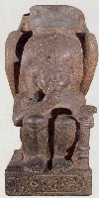 | Horus, the Egyptian god, a hawk, is protecting young Ramses.  Horus is the best god in Egypt, appearing as a bull, a sun god, and all seeing eye.  In ancient mythology, the best god is not the creator, but the god who rebelled against the creator.  So the creator or the god who had power before are always described as a bad god.  Horus fights and wins the kingship with his uncle(set) who killed his father Osiris in Egyptian mythology.
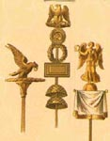 | The eagle is a symbol of the Roman Empire.  The eagle statue was also put forward when the army marched.  Rome inherited the faith of Babylon and Greece, and serve the emperor as a god.  Rome persecuted many Christians and martyred them.
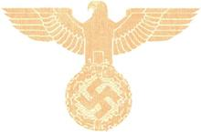 | The symbol of the German Nazi is also an eagle.  The eagle pattern was used for decorations or insignia.  Nazism was born with the help of the Catholic Jesuits, based on fascism, occult(mysticism), and eugenic racial supremacy.
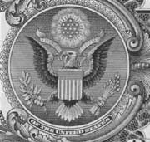 | The eagle behind the US dollar bill is the symbol of the United States and the symbol of Freemason, and it has 13 arrows and 13 olive leaf on its feet in accordance with 13 that Freemason thinks sacred.  There are 13 stars above the head of the eagle.  The ribbon that the eagle bites says E PLURIBUS UNUM, which means that many people will be united.  This means that when a world government is established, everyone lives under a dictator as a slave.

c) Lion
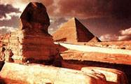 | It's a sphinx next to the pyramid of King Capre of Egypt.  The body is a lion and the head is the face of the pharaoh.  Sphinx is a lion, the head is a human face.
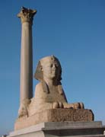 | Pomface Pillar and Sphinx in Egypt are well-known lion shapes of Sphinx.  The sphinx means "the strangler."  Egypt considers pharaohs to be equal to God, so it shows that pharaohs have the lion's body in the position of God.
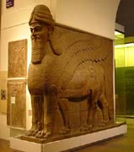 | It is a half-man half-beast column found in the temple of Nimroth in the Sumerian region.  The Sumerians built the world's first civilization in the Mesopotamian region.  He has a lion's body and wings.  It is currently kept in the British Museum.
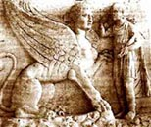 | It is a sculpture of Greek mythology, which Oedipus solves the mystery of the Sphinx.  The sphinx is riddled to the person passing by, but the person who can not solve is eaten.  Four in the morning, two in lunch, and three in the evening.  When Oedipus answered "man", the Sphinx hits the cliff and dies.
Ps.57:4 My soul [is] among lions: [and] I lie [even among] them that are set on fire, [even] the sons of men, whose teeth [are] spears and arrows, and their tongue a sharp sword.

d) Man
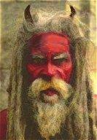 | It is the shape of King Zu, who actually appeared in Babylon and ruled.  There are horns on the red face.  The horns are derived from the horns of the bull.
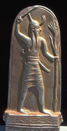 | It is the famous Baal god who served in the Kingdom of Tyrus (Phoenicia).  Baal entered Israel and the Jews served the Baal god, so they were judged by God and invaded by the foreign people.  It is hard to understand why Israel has left the good God as a chosen nation and had so persistently served the Baal.  This is because the forces of evil are more active to the believers chosen by God
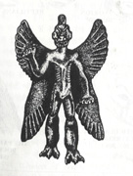 | It's a Satanic sketch that is often found in the Mesopotamian region.  There are four wings, and the shape of the face, hands and feet is similar to other demons.  This statue was also introduced in the movie Exorcist, suggesting that it is Satan's appearance.  The film Exorcist is a realistic depiction of the phenomenon of demonic possession based on the fact that it actually happened in the United States in 1949.
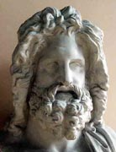 | 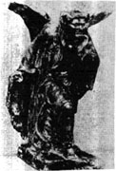 | 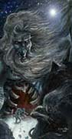 | 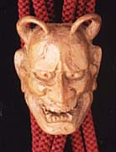
Zeus of Greece | ancient european rocky god | ancient european imir god | a satanic japanese mask

e) Goat
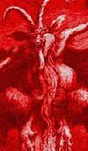 | 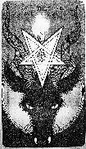
It is a goat god serving in ancient faith and has a large horn.  The goat is also a symbol of sinners in contrast to sheep in the Bible.  Satanic worship groups serve Satan as a goat. | It's a goat image that is often used as a symbol in the Freemasonry.  The distorted and upside down pentagon on the head of the goat is also a symbol of Freemasonry.

f) snake
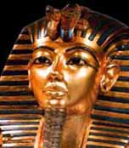 | There are two snakes on top of the mask covered in the mummy of the Egyptian pharaoh.  Egyptians sacred snakes, and they believed that snakes on the pharaoh's head protect the pharaoh.
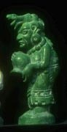 | 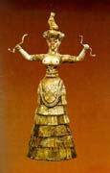 | 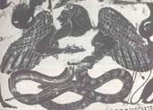
maya exten god | the serpent goddess of crete | greek thyphon god

g) Multiple arms, multiple faces, winged person, eye shape
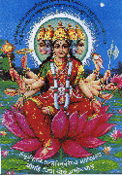 | The Hindu goddess of Gayatri has eight arms and five faces  The rounded glow on the face is a feature of the gods in ancient faith.  Lotus flowers are a symbol of sacredness for both Hinduism and Buddhism.
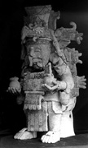 | 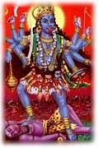 | 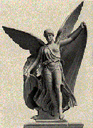 | 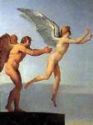
Maya chark god | india turga goddess | Greece Nike god | Greece Icarus
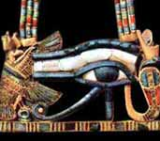 | Horus, the Egyptian god with the shape of eye.  Horus also appears in the shape of an eye, and Freemason accepts it and serves it as all seing eye.  In Buddhism and New Age, this eye is called the third eye, and it is the eye that can see the spiritual world.
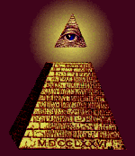 | It's a display that shines on the pyramid, the symbol of Freemasonry.  The pyramid symbolizes the Egyptian faith, and symbolizes a class society or kingdom.  The all seeing eye on the pyramid means that the Illuminati, which has been in the light of god, will dominate the world, and this picture is also behind the US dollar bill.  Ultimately, however, the all seeing eye represents a person, and the reality that no one knows is Satan (anti-Christ).

4. The shape of Demons
The fallen angel, the demons are shaped like ugly person, animal, monster.
They form a kingdom underground, form a class society like the army, and are absolutely loyal to Satan.
The devil corrupts the world, alienates the world from God, criminalizes it, and fights each other.
They receive great awards from Satan in their missions, and the number is incalculable.
The demons perform different duties, the demons that make them obscene, the demons that make them drugged, the demons that make them drunk, the demons that make them gamble,
There are demons that make you kill, demons that make you steal, demons that make you lie, demons that make you doubt, demons that make you idolatize.

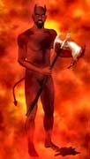 | 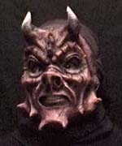 | 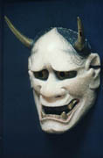
The shape of demon | western demonic mask | japanese demonic mask
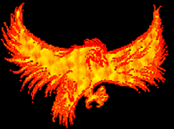 |  | 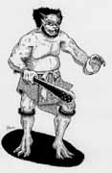
phoenix |  | japanese demon
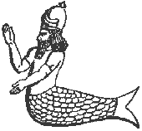 | 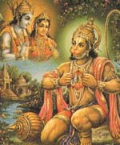 | 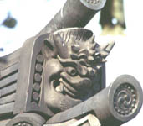
Dagon god | Indian hanuman | sumioni
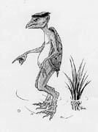 | 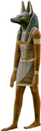 | 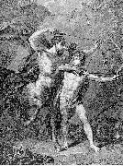
capa | Yanubis | kiton
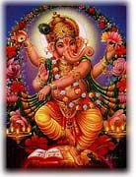 | 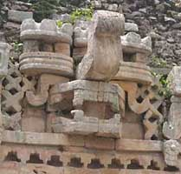 | 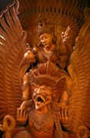
ganesa | Mayan god | garuda
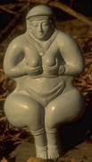 | 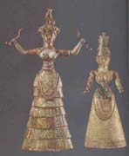 | 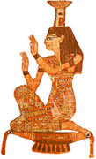
inanna | minos | nepris

5. Personality of Satan and devils
Satan was originally a righteous angel, but after his fall his personality was distorted and he became rebellious, destructive, arrogant, obscene, greedy, cunning and evil.
It becomes an incarnation of mean evil that does not have a conscience or a good heart, and governs the devils like a gang leader.
Matt.25:41 Then shall he say also unto them on the left hand, Depart from me, ye cursed, into everlasting fire, prepared for the devil and his angels:
Satan is trying to contaminate the beautiful earth and the people created by God and make them a dirty and smelly ugly world, and under his rule, he is trying to build the earth into his kingdom, not the kingdom of God.
Also, it is unfair to go alone in the eternal punishment of the fire, so one more person is corrupted and incites them to go together.
So let's look at the character of Satan and devils.
a) Satan defies the truth of God and shows a rebellious and destructive appearance.
All creatures worship God and live according to the laws of nature.
But Satan defies such a principle and shows a rebellious and destructive appearance.
For example, it is true that men and women love and marry and raise children.
They stimulate homosexuality to love the same sex, and they break families through cohabitation, free sex, perverted sexual activity, affair, divorce, and so on.

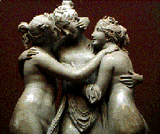
greece cartes goddess

b) Satan is a sadist who feels joy while harassing others.
Satan has no joy coming from heaven, so his heart is in agony, so he feels joy while harassing others, the most degrading joy.
When the unrelieved spirit comes to hell, Satan and the demons burn, harass, feel joy, and gain strength.
If someone else is suffering, it is God's heart(conscience) to feel sorry and help, but rather enjoy the harassment.

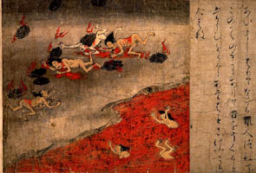 | 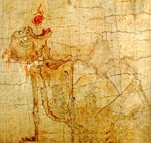
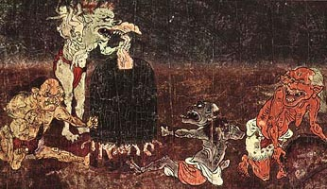 | 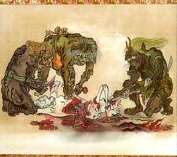
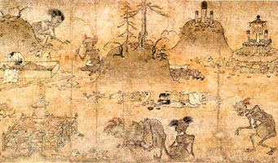 | 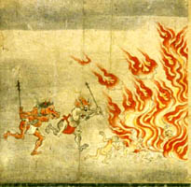

The picture above is about hell, demons and suffering spirits in traditional Japanese folk paintings.
Even before Christianity came in, each country had its own concept of suffering hell and demons..
If you search the search site for the term "jigoku zoshi", you can see the relevant data.

c) Satan is arrogant and greedy of matter.
Satan, whose wisdom was fulfilled and complete at the time of creation, was not grateful to God but became arrogant.
Satan, who managed the material, was greedy and wanted to occupy all the wealth of the heaven in an unjust way.
The angel seems not commit a crime because it is created good, but the angel has a free will like humans, so it is his mind whether he chooses the good or the evil.
Humans affected by Satan are also caught up in endless material desires and sacrifice others to fill their greed.
When you go to the court, you see a lot of family members suing each other for inherit.
Pride and greed are the source of almost all evil, which leads to disobedience to God.

d) Satan likes to kill people brutally, and is always angry.
Satan and demons are without conscience, brutally killing people and showing off their strength.
Serial killers brutally kill people, and damaging bodies is because they are affected by demons.
In fact, some of the murderers caught by the police confessed that "there is a demon in me."
There are many people who enjoy cruel and violent movies and games, but if you are interested, the demon is likely to come in.
The reason why Satan does this destructive work is because there is no love and joy in the heart and always there is hatred and anger.
Satan and the devils solve the anger filled in their hearts by doing terrible things.
Rev.12:17 And the dragon was enraged with the woman, and he went to make war with the rest of her offspring, who keep the commandments of God and have the testimony of Jesus Christ.

e) Satan likes to be obscene and perverted in pursuit of pleasure and debauchery.
Satan, who can not enjoy good joy, pursues evil joy.
But the physical joy is soon tired and wants more exciting joy.
So obscene demons go into people and want to corrupt them and get satisfaction through obscene and perverted sexual activity.
Now, pornographic sites that are flooded with the Internet are attracting people's attention with provocative screens through perverted sexual acts.
Something worse is happening than sodomism, such as same-sex love, incest, perverted sexual activity, group intercourse, and sadism.
All obscene site ads via e-mail or mobile phone are all temptations of demons, so please delete them boldly.
Col.3:5 Therefore put to death your members which are on the earth: fornication, uncleanness, passion, evil desire, and covetousness, which is idolatry.

6. Satan as shown in the Bible
It is no exaggeration to say that the Old Testament is a war that takes and takes away, God and Satan around Jews.
When God created Adam and Eve, Satan was jealous, and he made them criminal and moved them away from God.
Adam and Eve, who were deceived, were kicked out of the Garden of Eden, their relationship with God was cut off, and they suffered from disease and death.
Since then, Satan has ruled mankind on the condition of Adam and Eve's original sin.
The descendants of Adam and Eve, who are disconnected from God, have fallen, and God destroys mankind through flood judgment and save the Noah family.
However, the descendants of Noah became arrogant and built the Babel Tower, and God scattered them​to the world.
People servedl idols, but God callled Abraham.
The twelve sons of Jacob, the descendants of Abraham and Isaac, formed a nation in Egypt, and 400 years later, by God escaping from Egypt through Moses, giving the law in the wilderness and settling in the lands of Canaan, Israel was born.
Satan was trying to eliminate the Jewish people because he knew that the savior(Messiah) would appear among the Jews and restore humanity and destroy himself.
The first is to invade the Jewish people through the foreign people, and the second is to give the Jewish people a foreign civilization to serve idols and to be judged by God.
When Jews believed in God well, the country flourished, but when they served idols, they had to go through the invasion of the foreign people.
The prophets appeared several times and enlightened them to repent, but the Jews killed the prophets, rather than listening.
Israel flourished most during the David and Solomon kingdoms, but after that, idolatry make them divided and declined the kingdom.
Northern Israel, which served Baalsin, was destroyed first by Assur, and South Juda was destroyed by Babylon.
The country disappeared without trace and all were taken prisoner in Babylon, but the activities of prophets such as Daniel and Nehemiah did not abandon their faith.
Babylon was destroyed by Persia, and the Jews returned to their homeland and built the temple to prepare for the Messiah.
Jesus was born in Bethlehem as the king of Israel, the savior of the whole world, and the Messiah to destroy the devil, and gave the word of life, but the Jews did not believe and rejected him.

John8:44 "You are of your father the devil, and the desires of your father you want to do. He was a murderer from the beginning, and does not stand in the truth, because there is no truth in him. When he speaks a lie, he speaks from his own resources, for he is a liar and the father of it.
Jesus then said that the Jews are the children of the devil and greedy like Satan, so they do not recognize Jesus, the savior.
When the apostles who added the power of the Holy Spirit sent by Jesus shouted the gospel and Christianity prosperous, Satan persecuted through the Roman Empire for 300 years, but he could not break it, so Roman Catholic absolve Christianity.
When Luther and Calvin realized that something was wrong with non-biblical doctrines such as papal worship, Maria worship, indulgence, and confessionalism, Reformed in the 16th century, Roman Catholics slaughtered tens of millions of Christians but could not suppress them.
When persecution don't work, Catholics penetrate Christianity through the Jesuits, and then divide and fight, create liberalism and charismatism to abandon the fundamental beliefs, and then try to incorporate them under Catholicism again through the Ecumenical Movement.
Satan creates a lot of heretic churches with false revelations, leads people to the wrong path, creates New Age making people distant from God by inspiring them into superpowers, magic, meditation, yoga.
The purpose of Satan is to build a kingdom that serves himself on this land, and to elliminate pure Christians so that Jesus can not come back.
Even though all kinds of plots and plans for the establishment of the world government are underway, no one is clear.
But all of this will soon come to my eyes, and it will be a matter of my reality and a matter of soul salvation.

7. The master of imitation, Satan
If you read Egyptian mythology, Babylon mythology, Hindu mythology, Greek Roman mythology, it is quite similar to each other.
Not only that, but also similar to the Bible, the similarities found are as follows.
a) Ancient myths have a creation myth similar to the Genesis of the Bible.
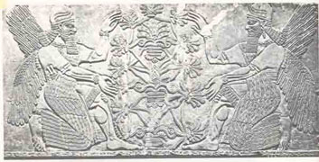
Gen.3:24 So He drove out the man; and He placed cherubim at the east of the garden of Eden, and a flaming sword which turned every way, to guard the way to the tree of life.
The above picture is a Beltis in Babylonian mythology, which protects the life tree.
It is true that it is Cherubim's mission to protect the life of the Garden of Eden, but he is acting a strange imitation even after being kicked out.

b) The best god is described as a king with a scepter.
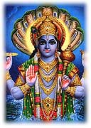 | 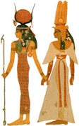 | 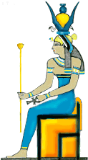
India Bishinu | Egypt Hator | Egypt Nut
Ps.45:6 Your throne, O God, is forever and ever; A scepter of righteousness is the scepter of Your kingdom.
The scripter is a symbol of royal authority, and Satan is posing as God on the ground.

c) The best god greets a man as a wife, and appears as a trinity.
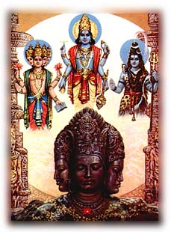 | 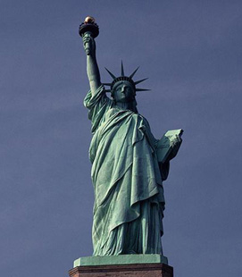

The above left photo, Brahma(above) is the Hindu creator, Vishnu(left) maintgain the world and Shiva(right) destroys the world.
Like the Trinity, worshiping a god leads to Brahma, and the most respected god is Vishnu.
Satan likes to be treated as son rather than the creator, and appears as a god of truth and light.
Please note that the Statue of Liberty, created by Freemasonry, is holding a lithograph(truth) in one hand and a torch(light) in the other.
Vishneu has four arms and several faces, and also appears as snakes and lions, served as a sun god, so must be Satan.
Vishnu sends 10 incarnations to the world, and the eighth incarnation is Krishna, which gives a similar image to Jesus, the shepherd.
The ninth incarnation is a Buddha, so absorbs Buddhism, and the 10th incarnation is said to be a savior who will come to judge the world in the future.
The goddess Shiva rides on a bull, similar to the Eulope of Greek mythology, who ride on a bull(Zeus).
The difference from the Bible is that the best God always rebels against the Creator and takes the throne.
To do so, the Creator is always portrayed as a bad God.
Horus of Egypt defeats the uncle set who killed his father, Vishnyu of India defeats the Devil's Lord Bali, and Zeus of Greece fights against the Tippon who eats his children.

d) Heroes kill bad dragons, snakes, or lions, and bring peace to them.
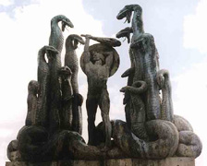 | 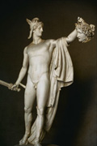 | 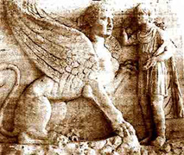
Hercules and hydra | Perseus cut off Medusa's neck | Oedips and Sphinx
In Greek mythology, Hercules kills the dragon god Echelos, Perseus kills Medusa with the head of a snake, and Oedips kills the sphinx with the lion body.
I could not understand that the just god killed the symbols of Satan, a counter-attack to show that Satan is a just god who destroys evil.
Just Oedips eventually reveals his satanic inner self by doing immoral work of killing his father and taking his mother.

e) The Son of God is usually born from virgin.
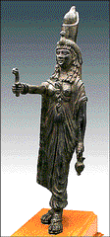 | 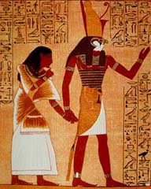
Egypt Isis | Egypt Horus
The Egyptian goddess of love, Isis whose husband Osiris died and goes to the afterlife, but she conceives with mysterious power and gives birth to her son, Horus.
Horus is Egypt's greatest god, appearing in many shapes of Satan.
It is a copy of Jesus being conceived by the power of the Holy Spirit from the virgin Mary.

f) The world is corrupted, the gods exterminate people in floods, and only one family survives.
According to Greek mythology, when the world becomes evil, fight each other, plunders, and don't worships to God, the gods judge the world with water and everyone dies, only the Deukalion and the Pura who are honest and worship to God survive.
It's similar to the Bible's Flood Judge and Noah's Ark story.

g) The best god is resurrected even if he die.
The god of Egypt, Osiris, dies in the trick of his brother set who coveted the kingship, but is resurrected from the underworld and becomes a god who governs death.
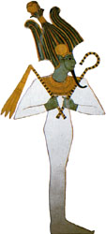

h) This world is destroyed by fire after judgment and a new world is opened.
In Hinduism, they believe that the universe has a circulatory and disappears after 10 billion years, and in the future, when the universe enters the destruction period, a white horse ride savior appears to defeat evil and save the law-abiding person to create a new universe.
As such, Satan follows the Bible from beginning to end, making it difficult for missionaries to preach the gospel.
The belief of Islam is surprisingly similar to Judaism, serving the only God, sacrifice sheep, not eating pork, and even aknowledge the Old Testament as a Bible.
The problem is that Jesus is not a savior but a prophet in Islam.
If you believe in Christianity in Saudi Arabia or Iran, a Muslim fundamentalist country, you will be severely suppressed.

8. Satan who possess and controls the world
Eph. 2:2 Wherein in time past ye walked according to the course of this world, according to the prince of the power of the air, the spirit that now worketh in the children of disobedience
The prince of the power of the air refers to Satan, where the air(space) means the universe or this world.
'The children of disobedience' means the person who does not believe in the gospel, and 'the spirit that works in children of disobedience' is Satan.
If people live accordig to the course(trends) of this world, it is like living in the will of Satan.
The conspiracy forces have long been planning to corrupt and fool the people in the world.
In the Zion Protocol written 100 years ago, before TV was invented, they wanted to make audiovisual tools and make people stupid, dominate people's consciousness through box office(movies, sports), and make quiz shows to make people slaves of money.
In fact, TV was invented by a Freemason scientist, and almost all of the world's leading Hollywood film companies are owned by Freemason, and American professional baseball owners are sponsored by Freemason.
The networks owned by Freemasons are sending out TV series about professional wrestling, childish low-quality comedy pros, and serial killers who brutally kill people.

9. Satan can possess the person who is not born again
2Cor.4:3~4 But even if our gospel is veiled, it is veiled to those who are perishing,
whose minds the god of this age has blinded, who do not believe, lest the light of the gospel of the glory of Christ, who is the image of God, should shine on them.
Paul said that the reason why the people do not accept the gospel is because something is covering the people who are not saved.
Among them, 'the god of the world'(Satan) darkens the hearts of those who do not believe, so that the gospel of the glory of Jesus, the image of God, does not shine.
In other words, no matter how good a person is, if he reject the gospel, it is not his heart but the heart of Satan.

Ex.3:6 Moreover He said, "I am the God of your father--the God of Abraham, the God of Isaac, and the God of Jacob." And Moses hid his face, for he was afraid to look upon God.
God appeared to Moses and said, "I am the God of Abraham, the God of Isaac, the God of Jacob."
This means that God, the Creator, is God of the Rebirth, and god of the Unrebirth is Satan.
In fact, in ancient civilizations such as Egyptian civilization, Mesopotamian civilization, Indus civilization, Inca civilization, Mayan civilization, Satan was the best god.

2Tim.2:26 and that they may come to their senses and escape the snare of the devil, having been taken captive by him to do his will
In other words, Satan appeared as the image of God to the people and gave them revelation, conveyed civilization, cared for, and served as God.
Even in this age, Satan can control the spirit(mind), soul(thought) and body(emotion) as well as the environment of a person who does not believe in Jesus.

Col.1:13 He has delivered us from the power of darkness and conveyed us into the kingdom of the Son of His love,
I was appalled when I realized that the thoughts that came to mind in the past, the sudden rising anger, the constant doubt, the anxiety and fear, the obscene thoughts, the depression and the disappointment were the demons' hearts.

Mark9:29 So He said to them, "This kind can come out by nothing but prayer and fasting."
Luke10:17 Then the seventy returned with joy, saying, "Lord, even the demons are subject to us in Your name."
Only Jesus has the power to expel dirty demons, so we can expel evil spirits in Jesus' name.
Also, even Christians can not be free from the influence of Satan unless they are born again with truth and the Holy Spirit.

* Let's look at the method in which the evil spirits govern humans.
a) Direct subjection
Satan and demons affect humans through direct and indirect subjection.
'Directly supervised' is a state in which a demon pushes the spirit of the person and becomes the owner and directly supervises it.
A person who is directly subjected to a demon becomes disconnect self-consciousness, and even if he or she becomes self-conscious later, he or she does not remember what he or she did.

Acts19:12~16 so that even handkerchiefs or aprons were brought from his body to the sick, and the diseases left them and the evil spirits went out of them.
Then some of the itinerant Jewish exorcists took it upon themselves to call the name of the Lord Jesus over those who had evil spirits, saying, "We exorcise you by the Jesus whom Paul preaches."
Also there were seven sons of Sceva, a Jewish chief priest, who did so.
And the evil spirit answered and said, "Jesus I know, and Paul I know; but who are you?"
Then the man in whom the evil spirit was leaped on them, overpowered them, and prevailed against them, so that they fled out of that house naked and wounded.
When a person who did not believe in Jesus used Jesus' name and drove out the demon, the demon possessed man said that "Jesus knows, Paul knows, who are you?" and attack him so he ran away.
In this way, it is directly supervised by the demon to enter the human body and become a completely different person and speak and act.
If a demon is possessed, he becomes stronger.
Multiple personality has many character within one person, and it turns up and lives according to its own personality.
Five multiple personalities can not be explained psychologically, and the biggest evidence that they are not the same person is that the five characters has different calligraphic styles.
Calligraphic style does not change, so other spirits come in and dominate the person.

Mark9:21~29 So He asked his father, "How long has this been happening to him?" And he said, "From childhood.
"And often he has thrown him both into the fire and into the water to destroy him. But if You can do anything, have compassion on us and help us."
Jesus said to him, "If you can believe, all things are possible to him who believes."
Immediately the father of the child cried out and said with tears, "Lord, I believe; help my unbelief!"
When Jesus saw that the people came running together, He rebuked the unclean spirit, saying to it, "Deaf and dumb spirit, I command you, come out of him and enter him no more!"
Then the spirit cried out, convulsed him greatly, and came out of him. And he became as one dead, so that many said, "He is dead."
But Jesus took him by the hand and lifted him up, and he arose.
And when He had come into the house, His disciples asked Him privately, "Why could we not cast it out?
So He said to them, "This kind can come out by nothing but prayer and fasting."
The evil spirit enters the person like above and makes him self-injury and attempts suicide.
It is also the devil's heart that makes us feel suicidal when we are in a difficult situation.
The devil is a spirit that bullies and kills, and if the devil drags a person to hell, the prize of Satan is big.
Jesus drives out the evil spirit and prevents it from coming back.
Because the house of evil spirits is a human body, evil spirits live in other people's bodies, and sometimes hundreds of evil spirits live in one person.
So how painful and hard feel a person who is possessed by evil spirits?
Jesus drove out the evil spirit, the evil spirit convulsed and left, and the person who was subject to the evil spirit seemed to be dead.
The person who lived with the power of the evil spirit, when the evil spirit left, become like the dead person who left his spirit.
When the person's self-spirit, which was kicked out by the evil spirit, came back to life.
Jesus says that these evil spirits can be driven out by prayer and fasting.
The best way is not to subject to the evil spirit, just as the light can not be invaded by the darkness, the demon can not even approach the person who is born again with the truth and the Holy Spirit.
1John5:18 We know that whoever is born of God does not sin; but he who has been born of God keeps himself, and the wicked one does not touch him.

b) Indirect subjection
Acts5:3 But Peter said, "Ananias, why has Satan filled your heart to lie to the Holy Spirit and keep back part of the price of the land for yourself?
Indirect subjectivity is what I thought I was talking and acting with my will in my conscious state, but it turns out that Satan and the devil did it.
Anania could not abandon her greed, concealed the value of the land, and lied to the Holy Spirit, and Peter said that Satan was full of her heart and lied.

Matt.16:23 But He turned and said to Peter, "Get behind Me, Satan! You are an offense to Me, for you are not mindful of the things of God, but the things of men."
When Jesus tells his disciples to go to Jerusalem and suffer and die and resurrect in three days, Peter holds Jesus with human thought.
Then Jesus shouts to Peter, "Satan, step back from me."
Peter is the first person to abandon everything and follow the Lord and admit Jesus as Christ and the son of God.
He would have been sad because he heard from Jesus that he was Satan.
But Peter's human thought and grabbed Jesus was done by Satan's indirect subjection.
The evil spirit achieves what he wants to do by managing his mind, thoughts and feelings, and enjoys the feeling together.
The way to distinguish it is to be born again and know it with feeling or to distinguish it by truth.
The evil spirits make me bully and die, and eventually lead to hell, but the Holy Spirit makes me help and live, and eventually leads to heaven.
Therefore, it is wise to get out of the domination of the evil spirit that surrounds me through Jesus and to be helped by the Holy Spirit.

* The following is a phenomenon that occurs when indirect supervision is received from a demon.
1. Repeated thoughts that you don't want to do, or you are obsessed with negative feelings.
2. He/she makes a ridiculous mistake, or makes a statement that hurts others, and regrets it later;
3. Always anxious and nervous and fear or worried about everything.
4. If hatred or anger suddenly rises, it cannot be suppressed and explodes.
5. He/she is not motivated by life, is lazy, and feels depressed or suicidal;
6. I cannot break up with my own strength in tobacco, alcohol, drugs, gambling, game addiction, etc.
7. I feel obscene and perverted thoughts, or love for the same sex.
8. No matter how much the hospital inspects it because of illness, there is no special cause, but my body mind are painful.
9. It is fun to lie, to cheat, or to do evil things.
10. Sometimes I feel the urge to kill, and I feel pleasure when I see cruel scenes in bizarre sites, violent movies, and martial arts.
11. Sometimes I feel happy to steal.
12. Feel joy when torment others or bully people.
13. If people around them ask to believe in Jesus, a severe rejection occurs.
14. Disbelief and suspicions about the spouse or the person around him/her are constant.
15. I hate people without knowing me.
16. The desire for money is constantly occurring.
17. Insomnia, nightmares, scissors, voice of evil spirits, or sleepwalking.
18. Nervous or unable to keep up with anything, and easily tires of it.
19. Satanic and destructive Rock music or rap music can not be cut off.
20. I am interested in mysticism or New Age.

Almost everyone is being bullied by evil spirits and does not know it.
I couldn’t control my mind and my thoughts, I was always anxious and afraid, worried, I was depressed, I was unable to escape obscenity, I was suffering from unexplained illness.
I wondered why this would happen to me who believed in Jesus and went to church.
John3:3 Jesus answered and said to him, "Most assuredly, I say to you, unless one is born again, he cannot see the kingdom of God."
The key to salvation is the 'born again'.
For those who are not born again, demons can harass the person at any time.
To born again I must believe that my old man has been crucified with Jesus, and I has become a new life resurrected with Jesus, and grow holy among grace and truth.
Satan and demons really exist, they are bloodless, tearless, cruel and vicious.
The pain and suffering of being bullied by Satan and the devil transcends our imagination.
My body and mind are so painful and hard that I only want to die.
In order not to be harmed by evil spirits, please acknowledge Jesus as a savior.

10. 15 elements that may be affected by Satan
1. Materialism, selfishness, and theft
2. Sexual depravity (same-sex relationship, incest, perversion, swapping, group intercourse, infant intercourse, intercourse, cedism, mesocism)
3. Rebellion, hatred, and revenge
4. Arrogance, luxury
5. Greed, power, and gambling
6. Magic, mysticism, superpower, and telepathy
7. Meditation, New Age, yoga
8. Hedonism, electronic game, sports, entertainment, movies, music
9. Tarot card, astrology
10. Murder, cruelty, violence, and bizarreness
11. Lies, fraud
12. Drinking, tobacco, and drugs
13. Thoughts of reincarnation and hypnosis
14. Humanism, rationalism
15. Suspicion, distrust, atheism, materialism, and evolution.

11. Conclusion
1John5:19 We know that we are of God, and the whole world lies under the sway of the wicked one.
The born again Christian belongs to God, but the whole world lies under the power of the devil.
Many unfortunate events, conflicts, corruption and suicides that happen in the world are caused by demons.
Even healthy people, people with money and power, pastors and deacons can not be free from the subject of the devil.
Above all, I can not win against the demons who control my mind, thoughts and emotions indistinguishable from myself.

James4:7 Therefore submit to God. Resist the devil and he will flee from you.
It was done 2000 years ago when the Jews killed Jesus, thinking it was righteous for God.
So the conclusion I came to is, 'I can't believe myself.'
If you are willing to do God's work without being reborn, you can do the work of confronting God under the supervision of Satan.

1John3:8 He who sins is of the devil, for the devil has sinned from the beginning. For this purpose the Son of God was manifested, that He might destroy the works of the devil.
The sinful man is captured by the devil, and even the believer who sins repeatedly has not been born again.
Jesus came to destroy the work of the evil Devil who presides over this world on the condition of sin.
Jesus has been punished for our sins on the cross, and has the power to drive out evil demons.

John15:5 "I am the vine, you are the branches. He who abides in Me, and I in him, bears much fruit; for without Me you can do nothing.
Jesus is a vine, and we are his branches, so we can not bear fruit without Jesus, nor can we do any good without Jesus.
In order to escape the power of the devil, you must abandon your stubbornness, thoughts and greed, and decide to live only according to Jesus' will.

Eph.6:11 Put on the whole armor of God, that you may be able to stand against the wiles of the devil.
In order to confront the cunning tricks of the Devil, we must wear a solid body armor with God's Word, grace, love and faith.
You have to study diligently and know the truth buried in the Bible and the conspiracy hidden in the world.
The Bible is not an old story that has nothing to do with me, but a book that is closely related to my salvation in this age.

Rom.16:20 And the God of peace will crush Satan under your feet shortly. The grace of our Lord Jesus Christ be with you. Amen.
The purpose of Satan is to build his kingdom on this land and make everyone worship Satan.
To this end, Theu are planning all kinds of plots, and everything is going on systematically.
The world's politics, economy, media, military, and U.N. are owned by the Satanic organization Freemason, and are ready to take the final steps through terrorism, war, and economic panic at any time.
We live in a huge Hollywood studio.
Everything around us is fake and fabricated, and no one doubts that these are fakes.
But when you find something strange, you can see that the black forces are sitting in the cockpit and controlling at will.

Matt.10:34 "Do not think that I came to bring peace on earth. I did not come to bring peace but a sword.
Jesus did not come to give peace to this world, but to give a sword to fight against the Satanl and win.
Religious problems cause conflicts with family members, and even if there is a dispute with friends or lovers, we must push it to faith.
The reason why we compare the word to the sword is that the word can descern right and wrong and can live properly.
Christians living in the end must fight with a sword of truth against the subjectionf Satan and the conspiracy of black forces.

