UFO (Species)

1. Species of UFO
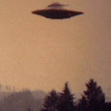 | Dome type  The dome protrudes in the center of the disk shape, and sometimes the dome emits light.  There are cases where there are protruding parts in the lower part.  It accounts for a large portion of UFO sightings.
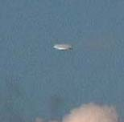 | Disk Type  It is a round, thin shape with a thickness less than one-fifth the width.  The term "flying dish" came out of a disc-shaped UFO.  As a result of classifying UFO types, disk type accounted for 16%.
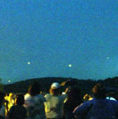 | Spherical type  It is the UFO type that is seen next to the disk type, and their size varies.  Also, spherical UFOs were made of metal and color depending on the state of the surface.  spherical type UFO was known as the Foo Fighter during World War II.
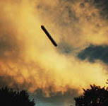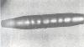 | Cigar type  The Cigar type UFO is divided into 2 types.  The first is a complete cylindrical, floating vertically or obliquely on the ground, and there are many spheres around.  The second type is a large cigar-shaped UFO that is seen at very high altitudes.  Unlike a complete cylindrical, the cigar type refers to a case where the center part is thicker than both ends.  It is generally seen by aircraft pilots and is known to be more than 10 meters to 100 meters long.
Triangular
One of the rare forms is the triangular UFO.
It was discovered in 1964 in Leak, England.
This triangle UFO was floating in the night sky with a red light with the sound of an electric motor.
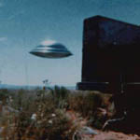 | Hemispherical type  It looks likes it has overturned a deep bowl.  It was seen in 1996 in Cuipapa, Brazil.
Conical type
A conical shape is protruding from the disk shape.
It was seen in 1974 in the U.S. state of North Carolina.
Rugby ball type
UFOs of rugby ball type have an oval shape like rugby balls.

2. Flight patterns of UFO
Unlike ordinary aircraft, UFOs have the ability that are very irregular and ignore aerodynamics.
UFO can surprisingly rotate at a sharp angle and rotate at a right angle during high-speed flights, and have the ability to disappear at a moment.
It can rapid-accelerate, rapid-surge, rapid-dive, and even dematerialize.
In addition to spiral flights, it has flight capabilities such as wave-like flights, zigzag flights, and momentary stops.
The flight of UFOs beyond these laws of physics is possible by distorting the surrounding space-time.
The UFO's flight principle, the anti-gravity device by electromagnetic field and the ion propulsion device by nuclear power, has been developed.
The U.S.government has been developing and operating UFOs a long time ago, but people don't know because they have kept secrets.
The instantaneous extinction is possible because Tesla has already moved the warship in time and space in the 1940s.

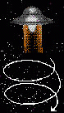 | Spiral flight  When UFOs rise, they make a spin in a screw shape.
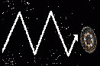 | zigzag flight  UFOs are doing zigzag flights at high speed.
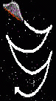 | fallen leaf drop flight  UFOs fall down during descending flights, sometimes flying as if falling leaves fall.
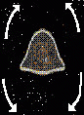 | fluctuating flight  When UFO stay in the air, it may fluctuate.
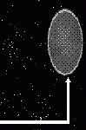 | rightangle rotation  It is against the laws of inertia.
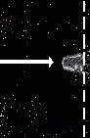 | extinction phenomenon  UFO suddenly disappears.

3. Species of aliens
a) Grey
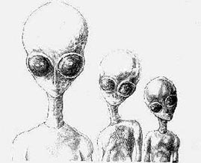 | 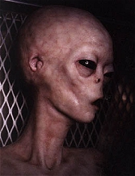
The right side of the picture is Gray, pictured in an underground secret lab in Utah, USA.
The most frequently seen alien is Grey.
They have large heads, large black eyes, and have small noss, mouth and ears.
Hands come to the knees, fingers are long and six.
The body color is mainly gray, but some are beige, tan, and pink gray.
They talk telepathically and send signals telepathically to humans.
They have no genitals, no sex distinctions, and are born by genetic manipulation.
So they kidnap human and livestock, do biopsy, and show great interest in genitals.
There are two grays, a large gray about 180cm tall, commands a small gray and does not work well.
A small gray, about 135 cm tall, is ordered by Leptalian and large gray, and is more like a humanoid than a creature.
Grays absorb nutrients directly through the skin and excrete the waste because the digestive organs are simple

b) Reptilian
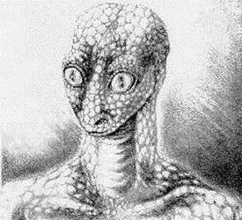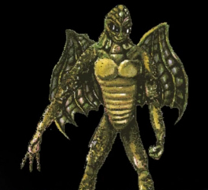

Reptilians are reptile, similar to snakes and lizards, their bodies covered in scales, their eyes open vertically, their eyes red, and they are born in eggs.
The skin is dark green, smells like snakes, the arms and fingers are long, the toes are four, one behind the ankle.
Like in the movie V, they can eat anything raw, and they can transform their appearance and make human appearance.
We usually think that reptiles are inferior to mammals, which is just preconceived.
Reptilians is more intelligent than we are, has a high scientific and technological civilization, and can use telepathy and superpowers.
They claim to be from the Draco(dragon) planetary system, and are also called Draconian.

c) Nordic
Nordics look similar to humans, but they are bigger.
Nordics look like North Europeans, have blonde hair and blue eyes.
They resemble Scandinavians and is named Nordic.
They are distinguished between men and women, are seen in UFOs after humans are kidnapped, and can use human language.

4. Characteristics of aliens

Bird Hopkins Defines the Characteristics of Aliens
Bird Hopkins, a UFO researcher in the United States who has studied many people in the world who claim to have been kidnapped by aliens for the past 30 years, has found that aliens have unusual common ground.
Bird, professional hypnotists, relived the memories of those who claimed to have been kidnapped by aliens and biopsy, and analyzed detailed information about aliens. It has been confirmed that aliens who kidnapped humans have the following characteristics.
1. Telepathy ability
Aliens can completely control human short-term memories.
They can control the nervous system to download images from the collected memories and consciousness, and insert new memories into the brain and consciousness.
The aliens suffer human through biopsy, but they can insert a favorable impression into the brain, control human behavior with telepathy.

2. Science and technology capabilities
The alien spacecraft can travel at a fairly rapid speed within the Earth's atmosphere.
They can freely control gravity to float or move people in the air, pass through house windows, car windows, and pass through any solids such as building walls, doors, brick walls.
Aliens can make electrical or motor vehicle starters useless if they want, and they can change their UFOs transparently so that they can not be seen by humans

3. The alien's inability;
There are things that aliens are incompetent and can't do.
Aliens can not read the writing written in human language.
Most aliens need a device that converts human language or mind into telepathy and delivers it.
Aliens cannot immediately understand human language and mind.
They can not use radio and can not communicate with TV, internet, telephone, wireless.
They don't understand that humans need to eat food for energy.
So the prisoners who were kidnapped for a few days were found hungry and dehydrated.
Aliens absorb nutrition through their skin and are sensitive to strong smells or gases, especially the smell of human perfume.
They are physically weaker than humans.
The aliens first retreat and then re-anaesthetize the situation when the kidnapped people wake up from telepathic anesthesia.
Aliens doesn't even know how to throw things.
Aliens can't do various moves that humans can do, and they don't know how to play ball in particular.

4. Difficulties of aliens
Spaceships carried by aliens are vulnerable to electric storms.
Their spacecraft was not designed to withstand lightning in the early days.
Weather data show that on the day of the UFO crash in Rosewell in 1947, thunderstorms was severe, which was a direct cause of the crash.
According to a video taken by NASA's space shuttle, UFOs are passing through thunder storms these days, so alien spacecraft seems to have been improved.

